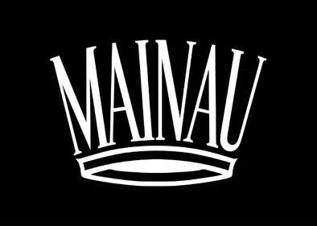

Press Information

Press Information

Mainau Flower Year 2019
“Sun, Moon and Stars”

The stars, distant galaxies and the vastness of the universe have always fascinated mankind. Under the annual theme “Sun, Moon and Stars” the Flower Year 2019 will be heavenly on Mainau Island. From March 22 – October 20, visitors can explore the exciting relationship between the celestial bodies, humans and nature in the botanical garden in Lake Constance.

The Orchid Show in the Palm House is the traditional launch of the Mainau Flower Year. From March 22 - May 5, the Orchid Show with the title "Infinite Vastness" invites visitors to journey through the universe. Colorful orchid arrangements represent planets and blue fabric panels symbolize the vastness of the universe. The orchid species Oncidium is the star of this year’s show. A very fitting choice because the flowers of Oncidium orchids and their relatives are usually a shade of yellow, a color most associated with sun, moon and stars.
On a tour through Mainau’s park and gardens, visitors will discover the solar system’s planets in wooden sculptures. This summer, a special ‘sun flowerbed’ dedicated to flowers that have ‘helio’ in their names (Helianthemum, Helenium, Heliopsis) will bloom on the palace lawn, between the historic Baroque ensemble and the gardener's tower. In the Energy Pavilion near the Butterfly House, visitors learn about the sun’s influence on organisms during photosynthesis. The annual theme also inspires the Mainau chefs to create various menu series and special events.
In cooperation with the Max Planck Institute for Astronomy, "Astronomy for All" is designed to immerse young and old into the fascinating world of stars and planets. This interactive exhibition runs May 10 - September 22 in Mainau Palace.
For the first time, the Berlin Anu Theatre will perform "Moraland" on the island from August 14 - 17. At night, illuminated areas in the park turn into another world where stories weave themselves around an imaginative fun-fair with curiosities and exciting things to discover.
The end of the Flower Year marks the autumn exhibition "Sunflowers!". From September 20 - October 20, the Palm House presents the sunflower family in all her glory — a diverse family that enriches the native garden not just with flowers, but food too.
Mediterranean Flowers and Children’s Adventure World
Alongside the island’s annual theme, there are numerous seasonal highlights including spring tulips in the thousands. As the year unfolds, lush rhododendrons, fragrant roses, countless perennials and colorful dahlias fill the gardens. The majesty of the 150-year old arboretum with giant sequoia trees is a shaded parkland to wander and daydream. Exotic palm trees and citrus plants give the island Mediterranean flair in summer. Children can explore the adventure playgrounds designed just for them, or go on a treasure hunt to discover the island.
Events:
Count's Island Festival: May 30 - June 2, 2019
Count’s Palace Festival: October 2-6, 2019
Sun Barbecue: July 14, 2019
Getting Here:
Attractive combined tickets for Mainau arrival and entry by train, bus and boat are available for example at German Railways (www.bahn.de/baden-wuerttemberg), Lake Constance Shipping Company (www.bsb.de) and Swiss Federal Railways (www.sbb.ch).

For more Events and Information: www.mainau.de.

Last updated: 03-2019
Further information for media representatives:
Mainau GmbH | Press Office
Tel.: +49 (0) 7531/303-138, Fax: +49 (0) 7531/303-160,
e-mail: presse@mainau.de

