UK Winter Highlights Release

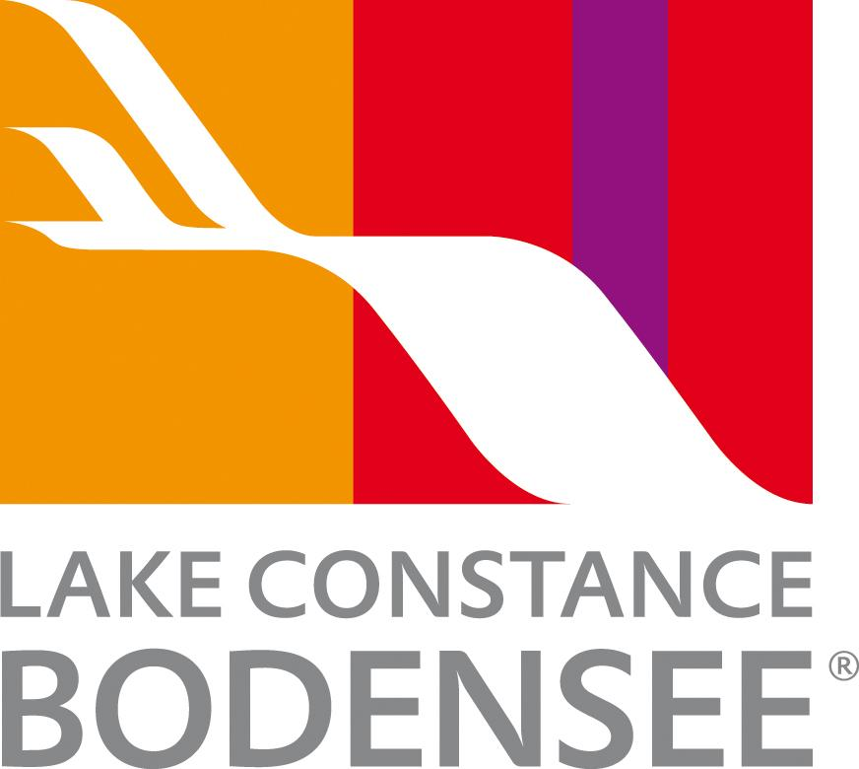

Winter wonders around Lake Constance - where four countries share the season

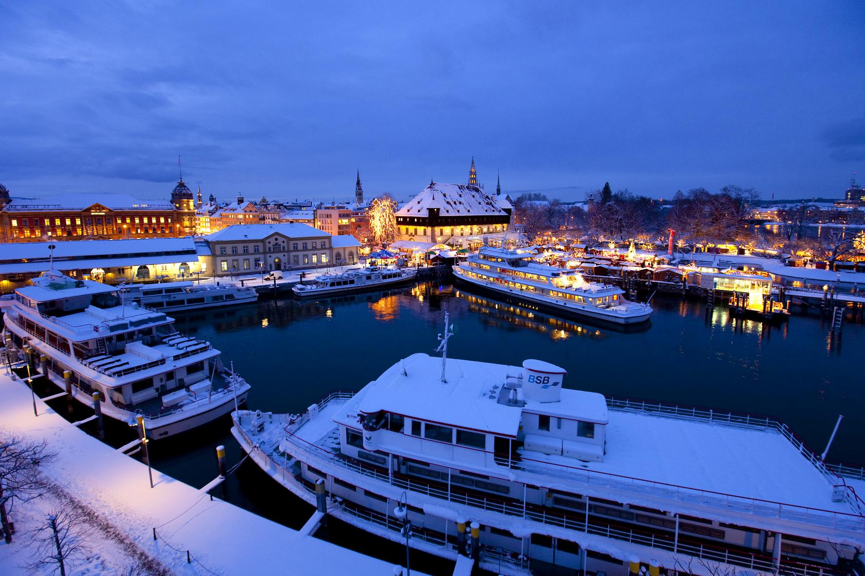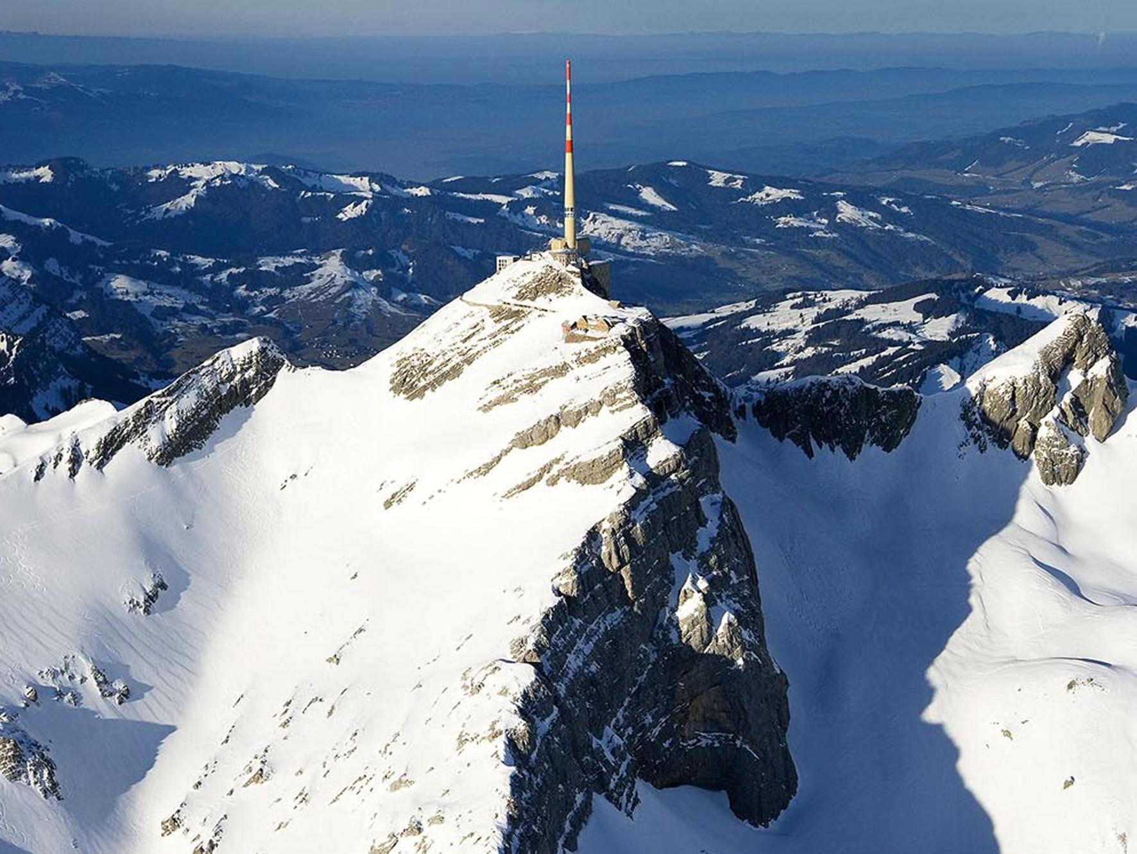
Link to high-res images here.

- Four-country winter: Snow sports, alpine adventures, and lakeside luxury across Germany, Austria, Switzerland, and Liechtenstein.
- Festive markets: Christmas markets in Lindau, Constance, Bregenz, and St. Gallen with crafts and local treats.
- Wellness escapes: Thermal baths, spas, and cosy hotels for winter relaxation.

When the first snow settles on the peaks above Lake Constance (Bodensee), the region transforms into a picture-perfect winter wonderland shared by Germany, Austria, Switzerland and the Principality of Liechtenstein. From alpine adventures and festive markets to steaming thermal baths and lakeside luxury, winter at Lake Constance brings together the best of four nations in one sparkling destination.

Snow sports and alpine adventure
Within a short drive of the lake, winter sports enthusiasts will find a variety of slopes, cross-country trails and cosy ski lodges surrounded by mountain scenery.
In Malbun, Liechtenstein, families and beginners can enjoy relaxed skiing and snowboarding on well-groomed runs with panoramic alpine views. Across the border in Austria’s Vorarlberg region, the resorts of Laterns and Bödele near Dornbirn offer a mix of gentle pistes and challenging descents - ideal for both day trips and longer stays.
Those seeking more extensive terrain can reach several renowned Vorarlberg ski areas within an hour’s drive, combining a lakeside base with mountain adventure. After a day in the snow, visitors can unwind with local cuisine and mulled wine at one of the region’s many rustic mountain huts.

Festive magic and winter markets
Lake Constance glows with festive charm each December, when its famous Christmas markets light up the towns and harbours along the shore. From Lindau’s Harbour Christmas with its lakeside stalls and twinkling lights, to Constance’s Old Town market, where traditional crafts and aromas of roasted almonds fill the air, every stop offers its own magic. Across the lake, Bregenz and St. Gallen host atmospheric Advent celebrations featuring choirs, skating rinks and artisan gifts. Full details can be found here.
Fun fact: the four-country region shares some of the oldest continuous Christmas market traditions in Central Europe - with Lindau’s first market recorded as early as the 16th century.

Wellness and winter warmth
For those seeking serenity rather than snow, Lake Constance is a haven of wellness and spa retreats. The newly reopened Meersburg Therme (May 2025) welcomes guests with panoramic pools overlooking the lake, while the Thermal Bath Überlingen and Therme Lindau combine modern architecture with restorative mineral waters.
Indulgent spa stays await at luxury hotels such as Traube am See in Friedrichshafen, Hotel Kaiserstrand in Lochau, and Golfpanorama Hotel in Lipperswil, Switzerland - each offering signature treatments, saunas and warm lake views.

Cosy escapes and seasonal offers
Winter is also the perfect time to embrace lakeside comfort. From boutique hideaways to family-friendly resorts, many hotels around the Bodensee region offer seasonal packages that blend relaxation with regional flavour.
Discover Wirthshof Hotel & Camping in Markdorf for spa breaks and yoga retreats, Hotel Hoeri am Bodensee for gourmet dining by the shore, or Hotel Storchen in Uhldingen for curated ‘Winter by the Lake’ packages featuring mulled wine evenings and guided winter walks.
Whether it’s the crunch of fresh snow underfoot, the scent of pine and cinnamon from festive markets, or the soothing warmth of thermal waters after a day in the mountains, winter around Lake Constance is a sensory delight.
Here, four countries come together to share the season - each adding its own traditions, flavours and landscapes to an unforgettable winter escape.
NOTES TO EDITOR
Getting there from UK:
- Flights: Direct flights from London, Manchester, and other major UK airports to Zurich, Memmingen and Munich. Limited direct flights from the UK into the closest airport, Friedrichshafen.
- Trains: Efficient links via German and Swiss rail networks; Zurich Airport is a key gateway, only 1 hour by train to Constance or St. Gallen.
- Ferries: Regular passenger ferries connect towns across the lake, offering scenic travel.
About Lake Constance:
The heart of Europe, one lake, four countries. The Lake Constance region, lovingly called ‘Bodensee’ by local residents, borders Germany, Austria, Switzerland and is just a short hop from the Principality of Liechtenstein. This international region benefits from magnificent views of the Alps. Visitors can choose to drive or cycle along rolling hills, past apple orchards and vineyards, visit Baroque churches and castles or take a dip in Europe’s third-largest freshwater lake.

For media enquiries please contact:
Alina Milz: milz@bodensee.eu
International Bodensee Tourismus GmbH
Hafenstrasse 6, 78462 Constance, Germany
Tel. +49 (0) 7531 / 909490 | Fax +49 (0) 7531 / 909430
office@bodensee.eu

For more information about Lake Constance please visit:
https://www.bodensee.eu/en
Follow on Social:
- Instagram: @bodensee.eu
- Facebook: https://www.facebook.com/bodensee.eu

