UK Culture & Events Release
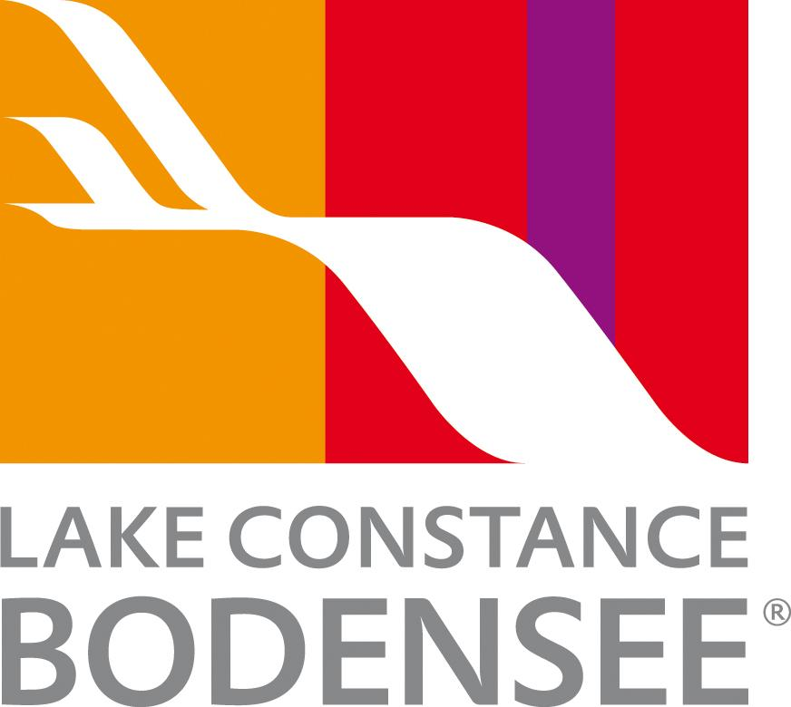

Culture, creativity, and celebration at Lake Constance

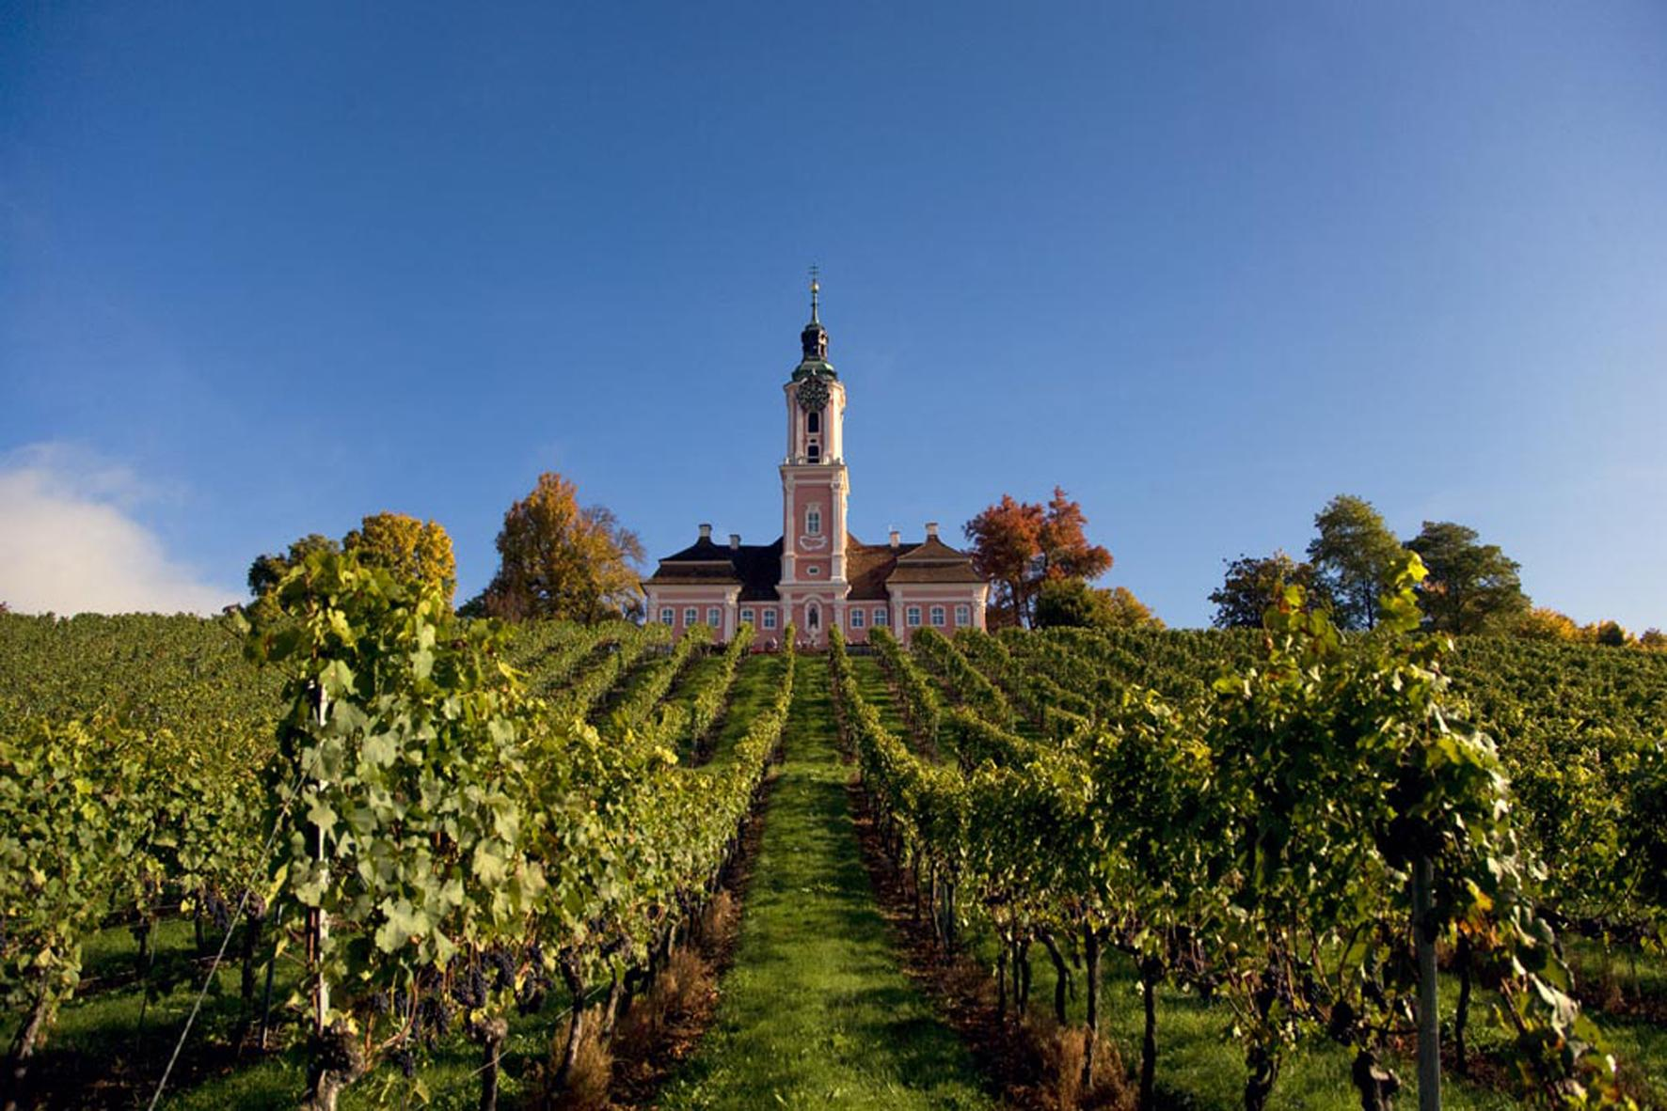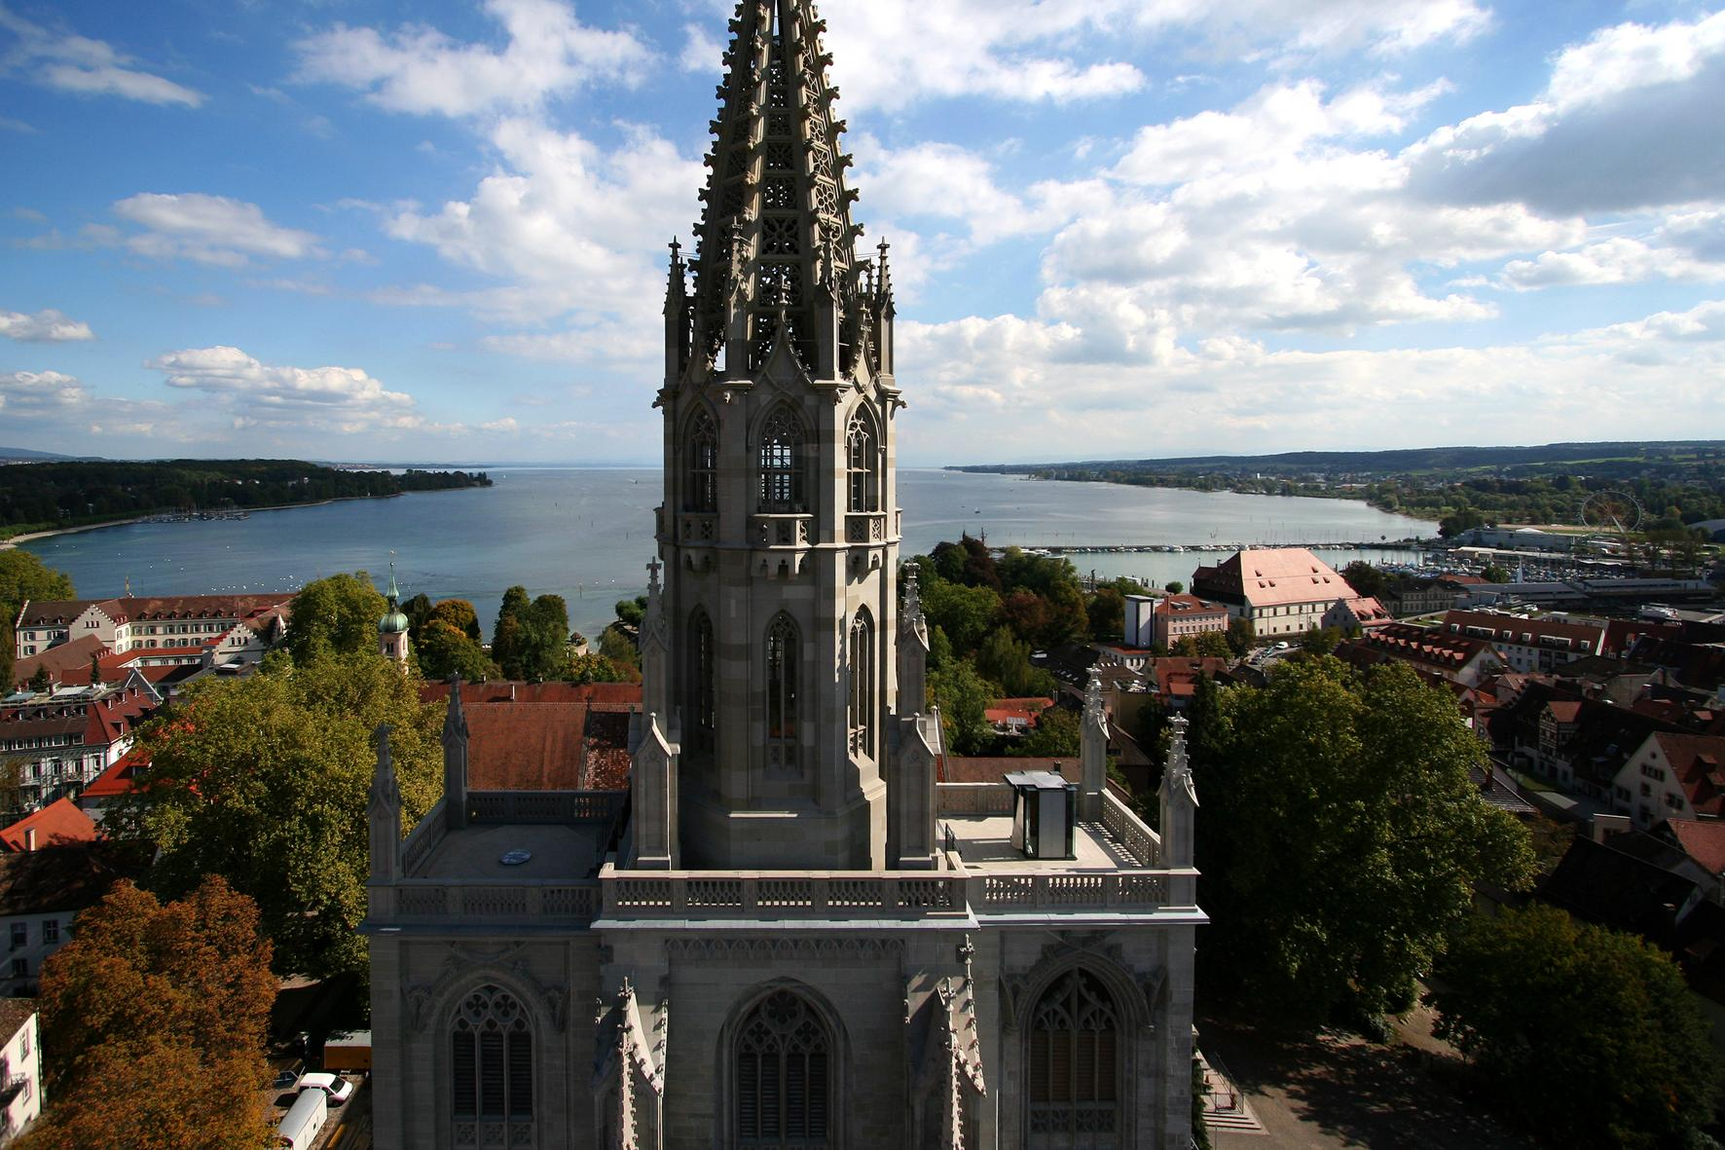
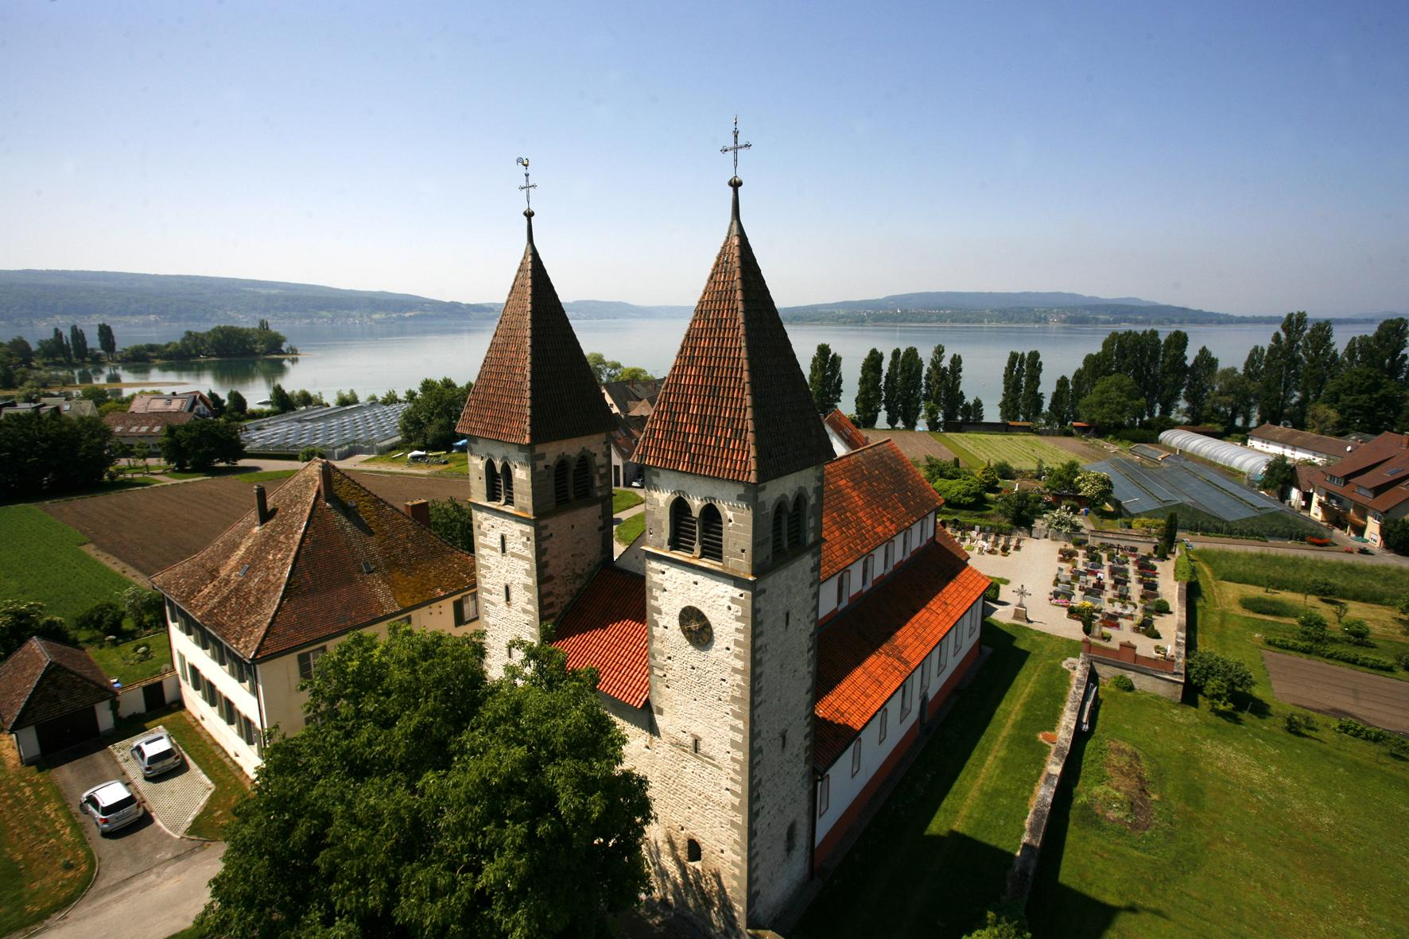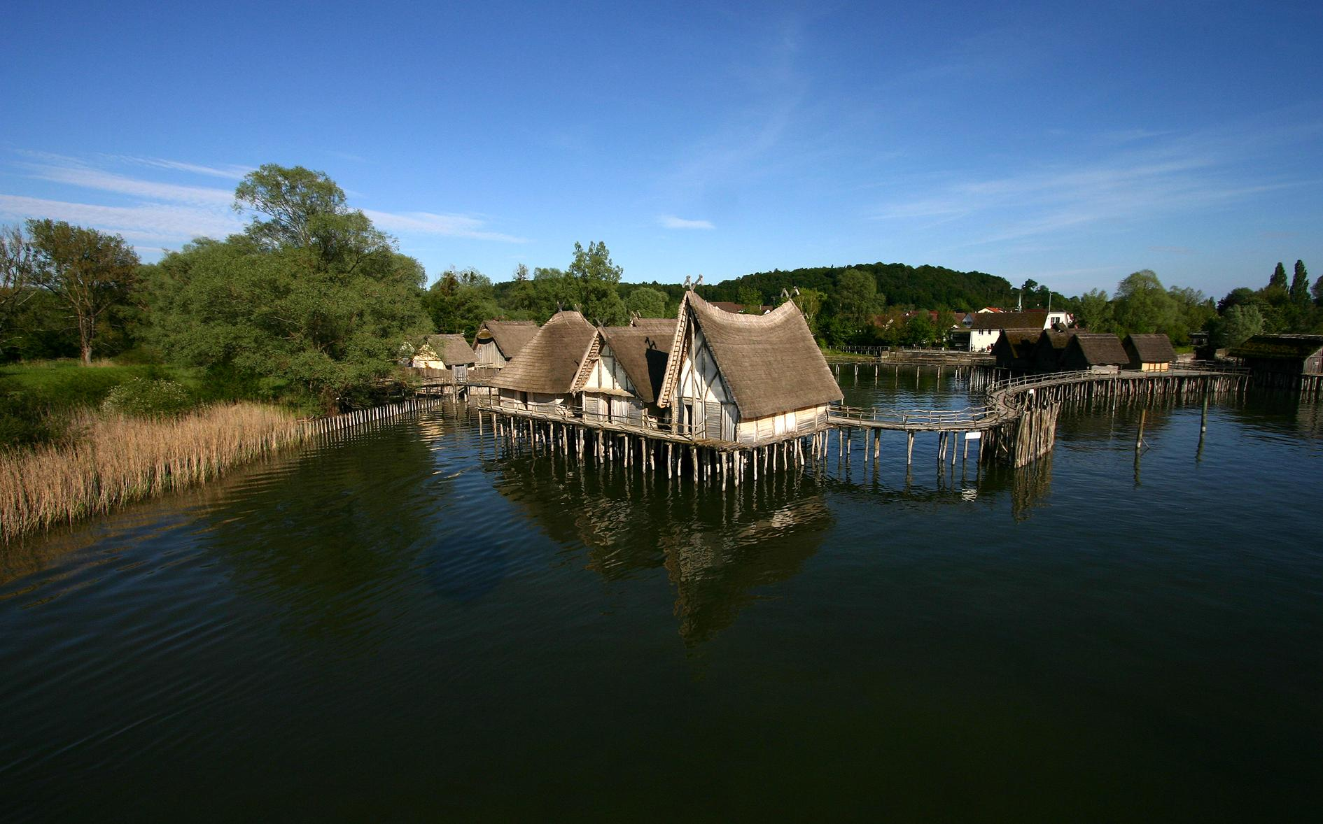
Link to high-res images here.

- UNESCO Treasures: Three World Heritage Sites that span millennia – from ancient lake dwellings to medieval abbeys.
- Castles and creativity: Baroque palaces, contemporary art museums, and festivals that celebrate the region’s rich imagination.
- Music, film and art: From opera on the lake to open-air festivals and avant-garde galleries.
- A year of celebration: Carnival traditions, festive Christmas markets, and the 80th anniversary of Austria’s world-famous Bregenz Festival in 2026.

Where Germany, Switzerland, Austria, and Liechtenstein meet, Lake Constance (Bodensee to locals) blends centuries of heritage, art, and celebration. It’s a place where Baroque towers rise above vineyards, modern art meets medieval architecture, and every season brings a new reason to explore.
UNESCO World Heritage Sites
UNESCO recognises only the world’s most significant cultural landmarks - and Lake Constance has three of them:
- Monastic Island of Reichenau (Germany) - Once the spiritual centre of Europe, this island is home to three early medieval churches with original frescoes, tranquil walking paths, and monastic gardens that trace centuries of religious history. Guided tours and visitor centres are open year-round.
- Abbey Library of St. Gallen (Switzerland) - One of the world’s oldest and most beautiful libraries, the Baroque Stiftsbibliothek houses over 170,000 priceless manuscripts and illuminated texts. Visitors can explore daily (entry from CHF 18, approx. £16.85 or one time free-admission with The Bodensee Card PLUS) - a must for lovers of books, architecture, and history.
- Prehistoric Pile Dwellings (Germany/Switzerland) – These fascinating lakeside settlements date back more than 5,000 years. The Pfahlbauten Museum in Unteruhldingen offers immersive exhibitions and reconstructed dwellings open March–November (adults €12 approx. £10.43).
Castles, Museums, and Cultural Highlights

From medieval strongholds to cutting-edge galleries, Lake Constance offers a wealth of cultural treasures across four nations:

- Burg Meersburg (Germany) - Germany’s oldest inhabited castle, perched above the lake. Wander through grand halls, dungeons, and armouries dating back to the 7th century. Open daily March–November (adults €14, approx. £12.19).
- Kunstmuseum Liechtenstein - A striking contemporary art museum in Vaduz, showcasing international modern and contemporary art in minimalist architecture. Open Tuesday-Sunday (adults CHF 15, approx. £14.15 - under 16 free)
- Kunsthaus Bregenz (Austria) - One of Europe’s most respected spaces for modern art, hosting thought-provoking rotating exhibitions. Admission €12 (approx. £10.45), open Tuesday–Sunday.
- Kunstforum Hundertwasser, Lindau (Germany) - Discover the vivid world of Austrian artist Friedensreich Hundertwasser at the lakeside Kunstforum Lindau. The venue hosts different installations: the opening exhibition “The right to dream” runs until 11 January, followed by a series of changing Hundertwasser exhibitions continuing through 2029. Each show explores the artist’s distinctive approach to color, ecology, and imaginative architectural visions.

Festivals and Events
From open-air operas on the lake to intimate village concerts, Lake Constance’s festival calendar celebrates music, art, and performance across four nations.

Bregenz Festival – July to August 2026 (Austria) - Celebrating its 80th anniversary, the legendary Bregenz Festival returns with large-scale opera performances on the world’s biggest floating stage. The 2026 programme promises spectacular new productions set against the dramatic backdrop of Lake Constance.

OpenAir St. Gallen – June 2026 (Switzerland) Switzerland’s largest outdoor music festival draws global artists and over 100,000 fans to the stunning Sitter Valley near St. Gallen. Expect world-class acts, sustainability initiatives, and a truly European festival vibe.

Summer OpenAirs in Meersburg, Salem, Markdorf & Friedrichshafen (Germany) All summer long, lakeside towns host intimate outdoor concerts and film screenings under the stars. Expect everything from classical performances to indie pop and jazz evenings.
Seasonal Magic: From Carnival to Christmas
From winter carnivals to twinkling Christmas markets, every season around Lake Constance brings its own magic and traditions to life.

Fasnacht (Carnival) – January to February 2026 - Experience one of Europe’s most colourful winter traditions. The Alemannic Carnival fills the streets with vibrant costumes, wooden masks, and raucous music. Towns such as Constance, Überlingen, and Bregenz burst into life as locals celebrate centuries-old folklore.

Christmas Markets – Late November to December 2025/26 - Lake Constance transforms into a winter wonderland with some of Europe’s most atmospheric Christmas markets. Don’t miss Constance’s old-town market, or Bregenz’s lakeside lights. Browse artisan crafts, sip mulled wine, and soak up the festive spirit.

UNESCO masterpieces, modern art, Carnival drums, and floating opera all come together at Lake Constance - a place where culture and creativity meet on the water’s edge. Whether wandering through medieval abbeys or dancing at open-air concerts beneath the Alps, every corner of this four-country region tells a story worth discovering.
NOTES TO EDITOR
Getting there from UK:
- Flights: Direct flights from London, Manchester, and other major UK airports to Zurich, Memmingen and Munich. Limited direct flights from the UK into the closest airport, Friedrichshafen.
- Trains: Efficient links via German and Swiss rail networks; Zurich Airport is a key gateway, only 1 hour by train to Constance or St. Gallen.
- Ferries: Regular passenger ferries connect towns across the lake, offering scenic travel.
About Lake Constance:
The heart of Europe, one lake, four countries. The Lake Constance region, lovingly called ‘Bodensee’ by local residents, borders Germany, Austria, Switzerland and is just a short hop from the Principality of Liechtenstein. This international region benefits from magnificent views of the Alps. Visitors can choose to drive or cycle along rolling hills, past apple orchards and vineyards, visit Baroque churches and castles or take a dip in Europe’s third largest freshwater lake.

For media enquiries please contact:
Alina Milz: milz@bodensee.eu
International Bodensee Tourismus GmbH
Hafenstrasse 6, 78462 Constance, Germany
Tel. +49 (0) 7531 / 909490 | Fax +49 (0) 7531 / 909430
office@bodensee.eu

For more information about Lake Constance please visit:
https://www.bodensee.eu/en
Follow on Social:
- Instagram: @bodensee.eu
- Facebook: https://www.facebook.com/bodensee.eu

