UK Culinary Release

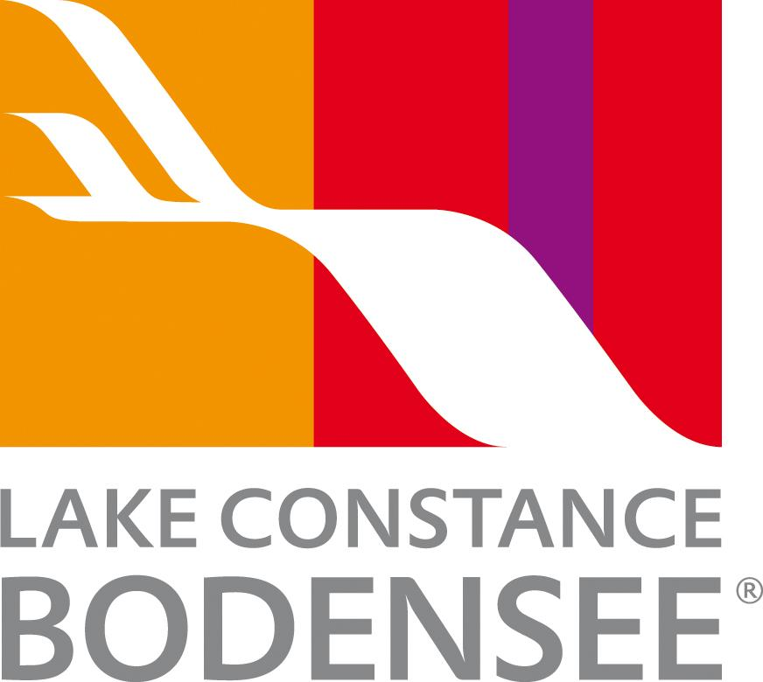

Culinary delights around Lake Constance - where four countries meet on a plate
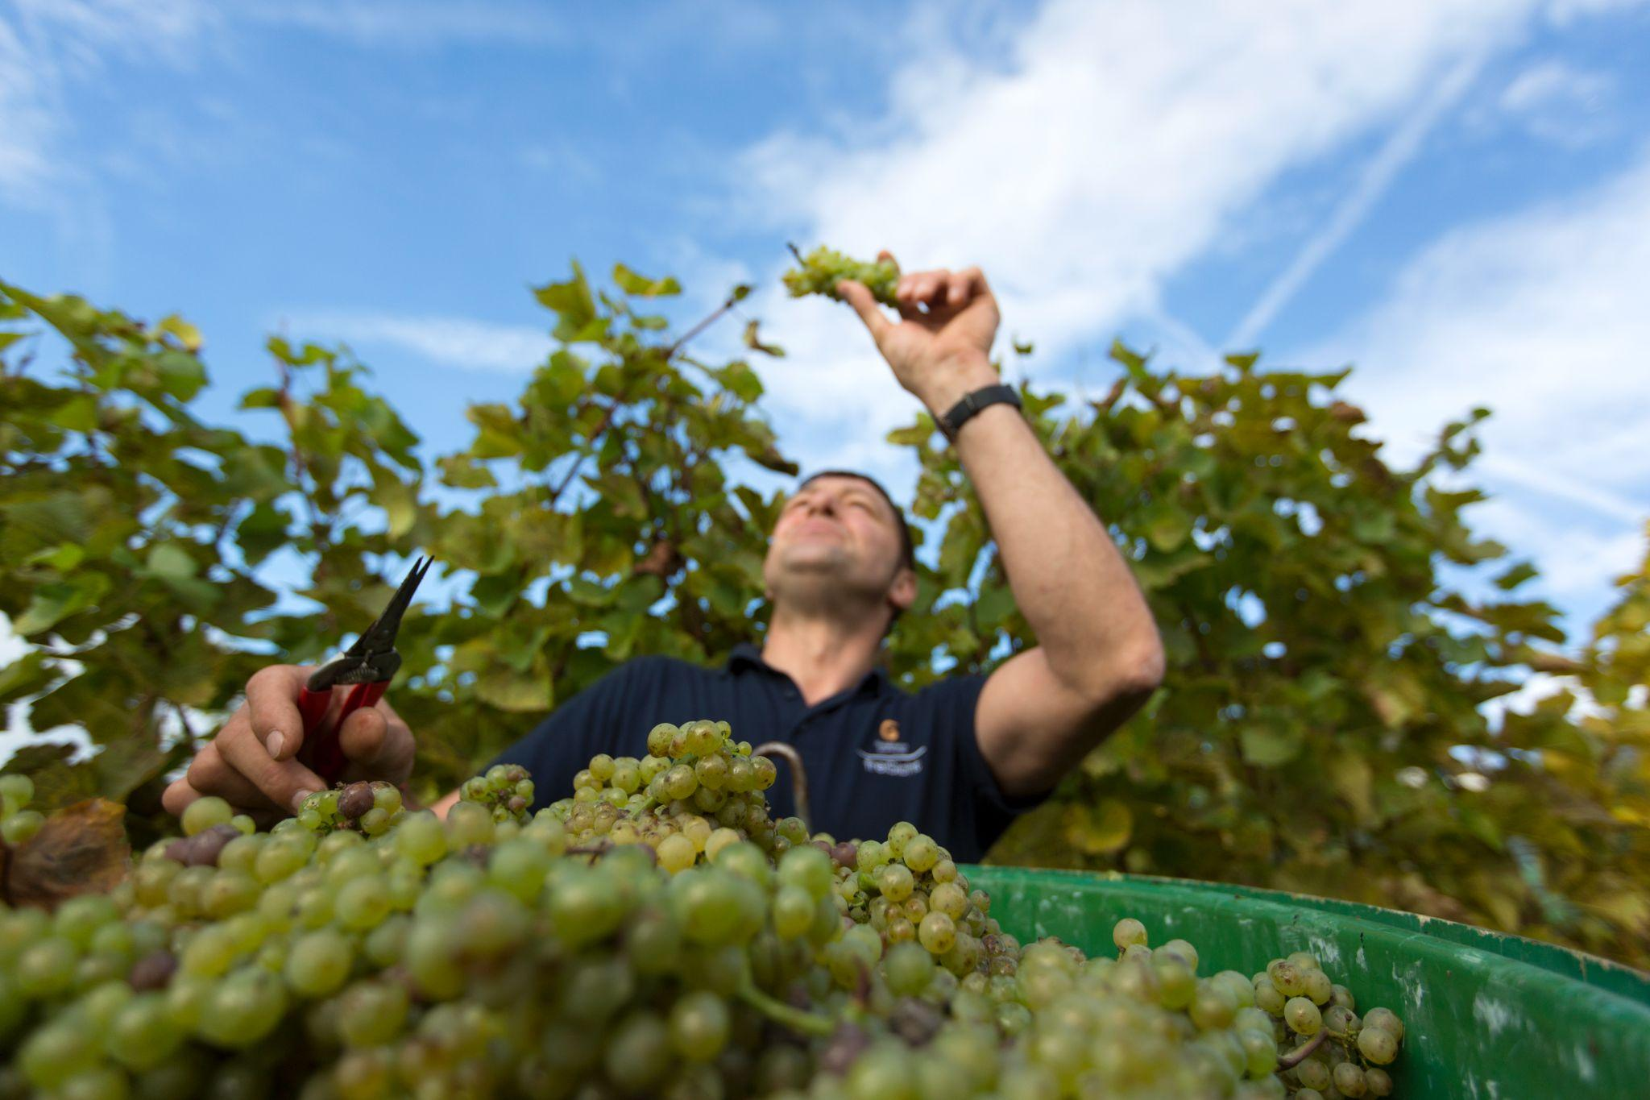
Link to high-res images here.

- Culinary crossroads: Lake Constance spans Germany, Austria, Switzerland, and Liechtenstein, offering diverse regional dishes.
- Local and seasonal: Chefs highlight farm-to-table produce, fresh fish, Alpine cheeses, and wines.
- Autumn food festivals: ‘Genussherbst’ celebrates harvest markets, fish weeks, and wine events.

At the heart of Europe, where Germany, Austria, Switzerland and the Principality of Liechtenstein meet, Lake Constance offers a rich tapestry of culinary experiences shaped by its shared borders, fertile landscapes and deep-rooted food traditions. From lakeside fish specialities and artisan wines to organic vegan dining and autumn harvest celebrations, the region is a paradise for food lovers seeking authentic flavour and regional character.

Farm-to-table flavours and fine dining
Across the Bodensee region, chefs and producers embrace the ‘farm-to-table’ philosophy, pairing local produce with culinary creativity. In Friedrichshafen, the TressBrüder Bio-Museumsrestaurant offers inventive organic vegan and vegetarian cuisine in a historic lakeside setting, while in nearby Meersburg, the Burg-Café serves homemade cakes and coffee with panoramic views over the vineyards and water.
For those who love a traditional Alpine touch, Restaurant Mangold in Lochau, Austria, is a celebrated fine-dining destination showcasing regional ingredients with modern flair. In Liechtenstein, Restaurant Masescha combines mountain views with refined yet rustic dishes, featuring seasonal vegetables, game and cheeses sourced from local farms.
Travellers can also enjoy classic hospitality at Gasthaus Grüner Baum in Moos, where chef Hubert Neidhart champions sustainable, locally sourced ingredients. ‘Cooking around Lake Constance means working with nature - fish fresh from the lake, apples from the orchards, and wines from the slopes above the shore,’ says Neidhart. ‘It’s about letting the region speak through every dish.’

Cafés and breweries with character
The region’s café culture is deeply rooted in history. In St. Gallen, Switzerland, the city’s Erststockbeizli - traditional first-floor taverns - serve hearty local fare in atmospheric wood-panelled rooms. On Mainau Island, the elegant Schloss-Café offers sweet treats and floral-inspired desserts in the castle gardens.
Beer lovers shouldn’t miss the Hopfengut No20 brewery, hop museum and restaurant near Tettnang, where guests can sample craft brews made with locally grown hops - a tradition dating back to the 12th century.

Seasonal produce and regional specialities
Throughout the year, Lake Constance’s markets brim with fresh produce - from cherries and apples to Reichenau Island vegetables and Alpine cheeses. In autumn, menus highlight wild game, mushrooms, pears and pumpkin, while vineyards produce new vintages of Müller-Thurgau and Pinot Noir.

Signature dishes include:
- Käsknöpfle – cheesy noodle dumplings topped with fried onions
- Bodensee Felchen – tender whitefish served grilled or poached
- Reichenau vegetables – seasonal greens from the UNESCO-listed island gardens
- Apfelküchle – apple fritters dusted with cinnamon sugar

Autumn harvest celebrations
Autumn is one of the most flavourful times to visit. The region’s Genussherbst (‘Autumn of Indulgence’) programme features a series of gourmet festivals and events across the four countries. Highlights include:
- Fish Weeks in Constance, celebrating freshly caught Bodensee fish
- Wine festivals around Meersburg and Hagnau
- Triesenberger Wochen in Liechtenstein, showcasing mountain specialities
- Harvest markets bursting with local fruit, cheeses, and preserves
Visitors can sample regional delicacies, meet winemakers, and experience the convivial spirit that defines the Bodensee’s culinary scene.
From vineyard terraces to lakeside terraces, Lake Constance invites travellers to savour the rhythm of the seasons. Spring brings tender asparagus and orchard blossoms; summer offers crisp wines and open-air dining by the water; autumn celebrates abundance and harvest; and winter brings comfort with cheese fondues and warming schnapps.
Whichever time of year you visit, the Lake Constance region serves up more than food - it offers a taste of life shared between four nations, each adding its own spice to the story.

NOTES TO EDITOR
Getting there from UK:
- Flights: Direct flights from London, Manchester, and other major UK airports to Zurich, Memmingen and Munich. Limited direct flights from the UK into the closest airport, Friedrichshafen.
- Trains: Efficient links via German and Swiss rail networks; Zurich Airport is a key gateway, only 1 hour by train to Constance or St. Gallen.
- Ferries: Regular passenger ferries connect towns across the lake, offering scenic travel.
About Lake Constance:
The heart of Europe, one lake, four countries. The Lake Constance region, lovingly called ‘Bodensee’ by local residents, borders Germany, Austria, Switzerland and is just a short hop from the Principality of Liechtenstein. This international region benefits from magnificent views of the Alps. Visitors can choose to drive or cycle along rolling hills, past apple orchards and vineyards, visit Baroque churches and castles or take a dip in Europe’s third-largest freshwater lake.

For media enquiries please contact:
Alina Milz: milz@bodensee.eu
International Bodensee Tourismus GmbH
Hafenstrasse 6, 78462 Constance, Germany
Tel. +49 (0) 7531 / 909490 | Fax +49 (0) 7531 / 909430
office@bodensee.eu

For more information about Lake Constance please visit:
https://www.bodensee.eu/en
Follow on Social:
- Instagram: @bodensee.eu
- Facebook: https://www.facebook.com/bodensee.eu

