US Quirky Facts Release

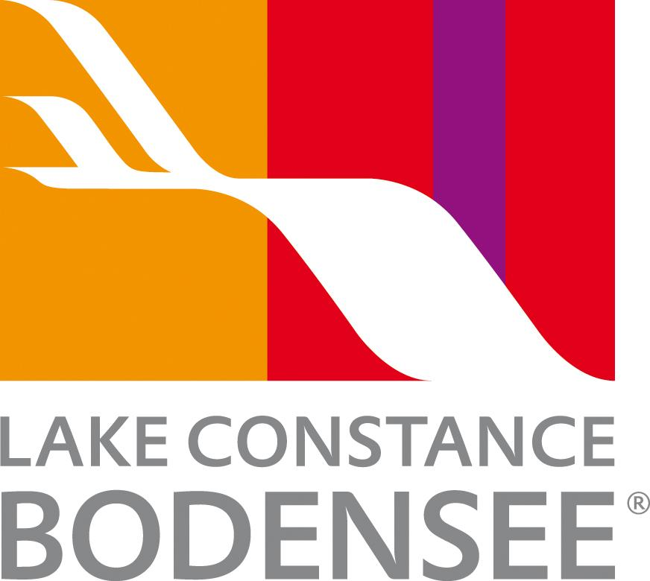

15 fun facts about Lake Constance - Bodensee

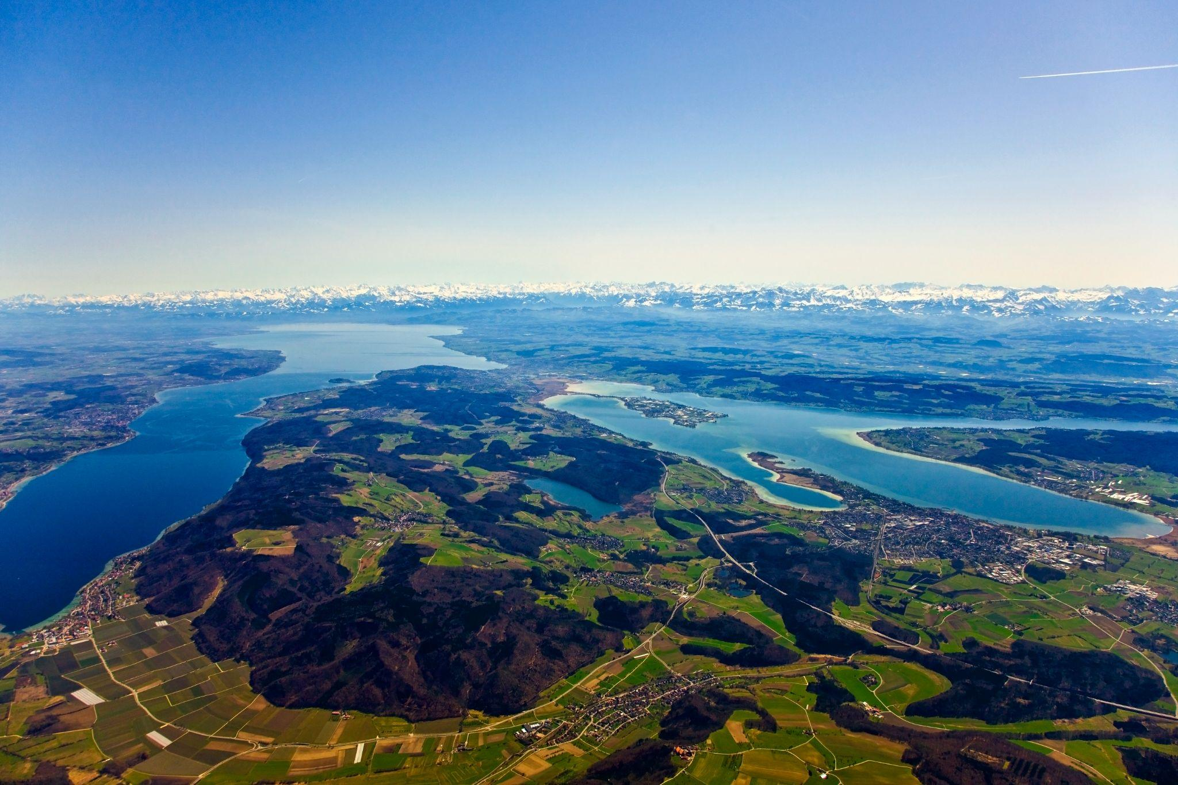
Link to high-res images here.

Lake Constance, or Bodensee as locals call it, sits at the heart of Europe where Germany, Switzerland, Austria, and the Principality of Liechtenstein meet. Known for its stunning scenery, UNESCO World Heritage Sites, and year-round activities, the lake also hides some wonderfully strange and surprising facts.

- No borders on the water! When you’re in a boat, Lake Constance is technically a shared international ‘no-man’s-lake.’
- Cycle across three countries - The Bodensee Radweg (Lake Constance bike path) stretches over 161 miles (260 km) through Germany, Austria, and Switzerland.
- Constance survived WWII - One of the only German cities untouched in the Second World War because it was mistakenly thought to belong to Switzerland.
- Zeppelins still fly – Count Zeppelin built his first airship over the lake in 1900, and today modern Zeppelins give visitors panoramic aerial views.
- Historic ferries - Some ferries have been running the same routes for over a century, linking towns much as they did in the 19th century.
- The world’s biggest floating stage - The Bregenz Festival stage holds a Guinness World Record and appeared in the 2008 James Bond film Quantum of Solace.
- Illegal grape smuggling… for wine! - In 1925, vines were smuggled from Switzerland to Germany to grow Müller-Thurgau grapes, now used in famous wines like Liebfrauenmilch.
- Bird paradise - The Lower Lake is a key stopover for migratory birds, making it a must for birdwatchers. Click here to find out which bird species can be observed in the different months.
- Frozen over rarely - The last ‘Seegefrörne’ (frozen lake) was in 1963; the lake freezes only once every 70 years.
- Europe’s drinking water - Lake Constance provides up to four million households with fresh water every day.
- Rhine Falls: Europe’s biggest waterfall - In summer, 600,000 liters of water crash over the falls every second.
- English gardens in Switzerland - Wartegg Castle in Rorschacherberg has English-style landscaped gardens designed in 1860 for Empress Zita.
- Stone Age on stilts - UNESCO-protected prehistoric pile dwellings along the lake reveal life over 4,900 years ago.
- Lake Constance’s own dragon legend – Locals tell of the ‘Lindau Dragon,’ a mythical lake creature that inspired folklore across the region.

- Flower Island Mainau – Known as the “Island of Flowers,” Mainau is home to over 500,000 blooming plants each year, including rare tropical and Mediterranean species.

Key Facts about Lake Constance
- Lake size and dimensions - Spanning 39 miles (63 km long) and up to 9 miles (14.8 km wide). Lake Constance has a max depth of 254 meters in the upper Lake and 147.4 meters in the Lake Uberlingen.
- Territory - with three nations bordering Lake Constance, the land and shores are divided up as follows: Germany: 55%, Switzerland: 34%, Austria: 11%.
- Average annual temperature: 46–52°F (8–11°C)
- Freshwater lake: Europe’s third-largest by volume
- The population around Lake Constance: is approximately 450,000 to 500,000 people.

NOTES TO EDITOR
Getting there from US:
- Flights: Major U.S. airports connect to Zurich and Munich, with limited flights to Friedrichshafen. Zurich is only one hour by train to Constance or St. Gallen.
- Trains: Efficient German and Swiss rail networks make it easy to reach towns around the lake.
- Ferries: Regular passenger ferries connect lakeside towns, offering scenic and leisurely travel.
About Lake Constance:
The heart of Europe, one lake, four countries. The Lake Constance region, lovingly called ‘Bodensee’ by local residents, borders Germany, Austria, Switzerland and is just a short hop from the Principality of Liechtenstein. This international region benefits from magnificent views of the Alps. Visitors can choose to drive or cycle along rolling hills, past apple orchards and vineyards, visit Baroque churches and castles or take a dip in Europe’s third largest freshwater lake.

For media enquiries please contact:
Alina Milz: milz@bodensee.eu
International Bodensee Tourismus GmbH
Hafenstrasse 6, 78462 Constance, Germany
Tel. +49 (0) 7531 / 909490 | Fax +49 (0) 7531 / 909430
office@bodensee.eu

For more information about Lake Constance please visit:
https://www.bodensee.eu/en
Follow on Social:
- Instagram: @bodensee.eu
- Facebook: https://www.facebook.com/bodensee.eu

