US General Release

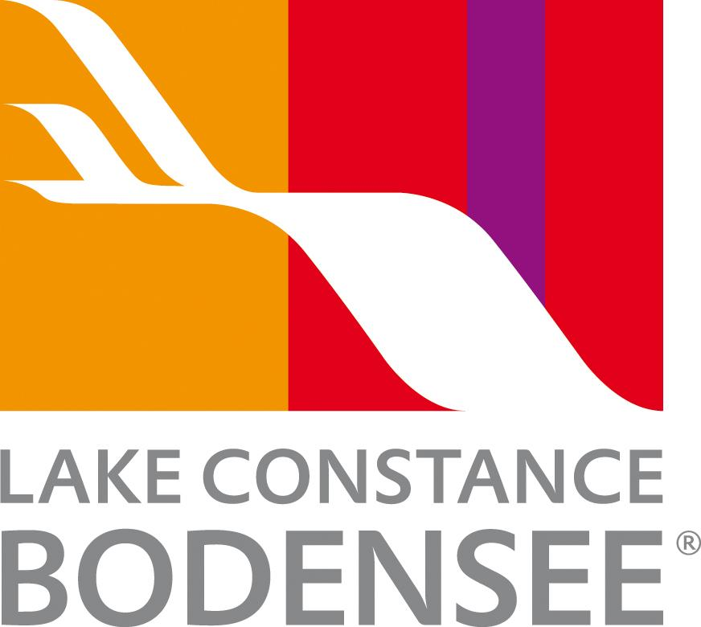

Lake Constance: A quintessential European destination

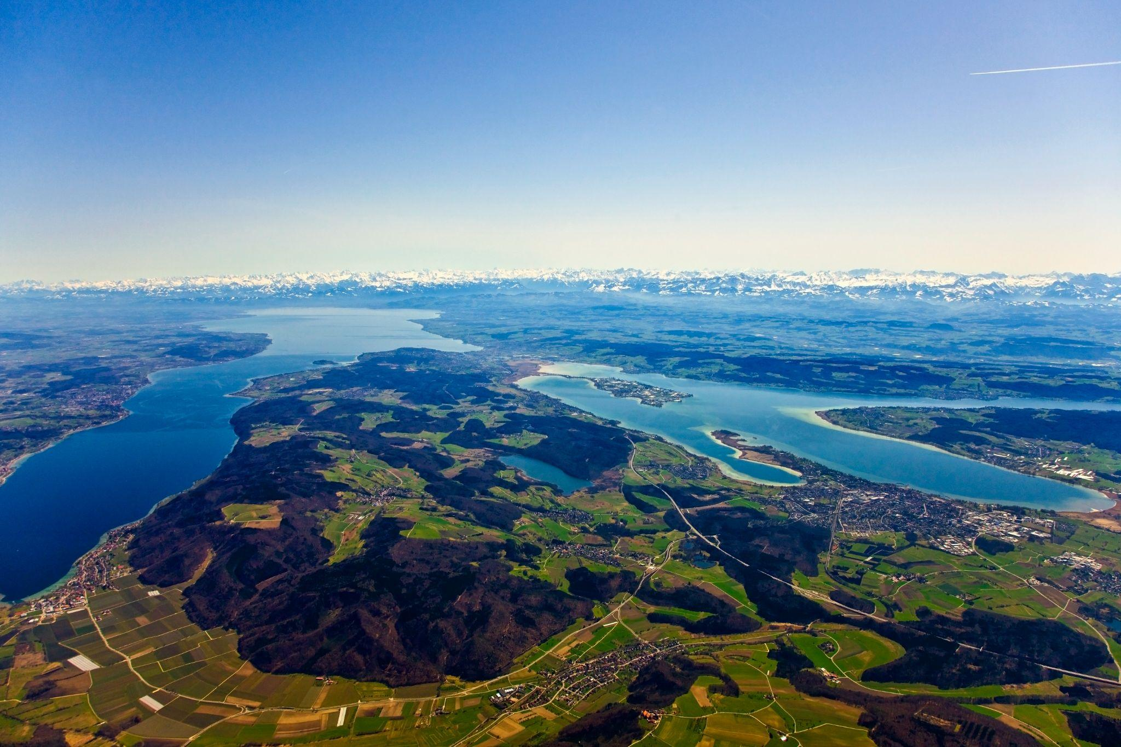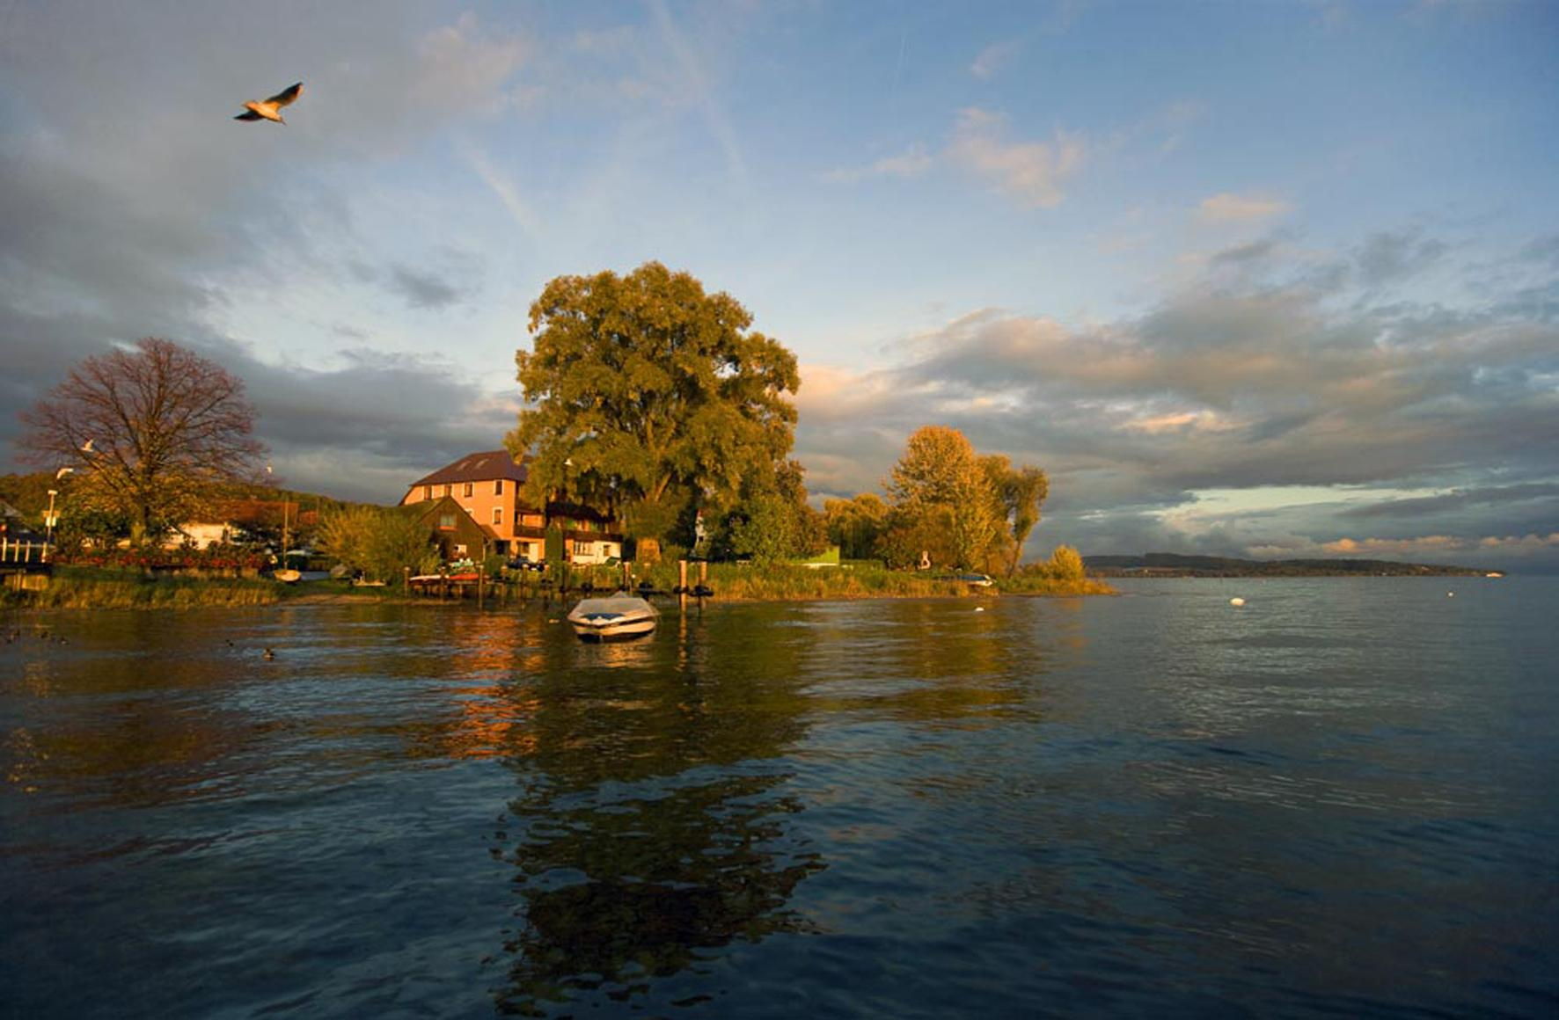
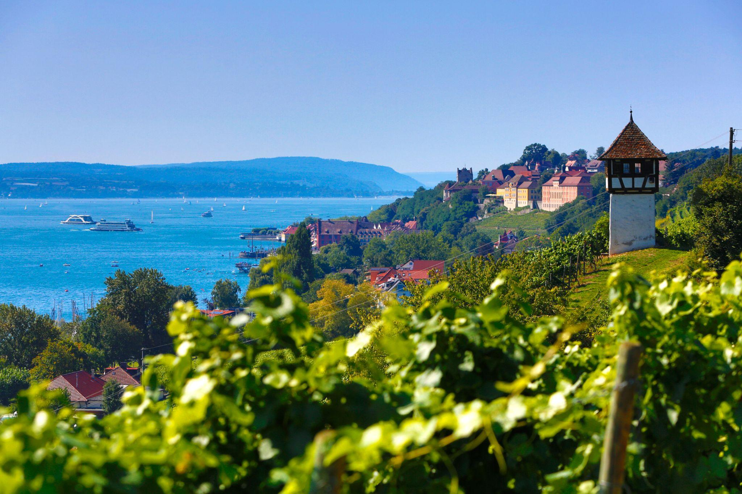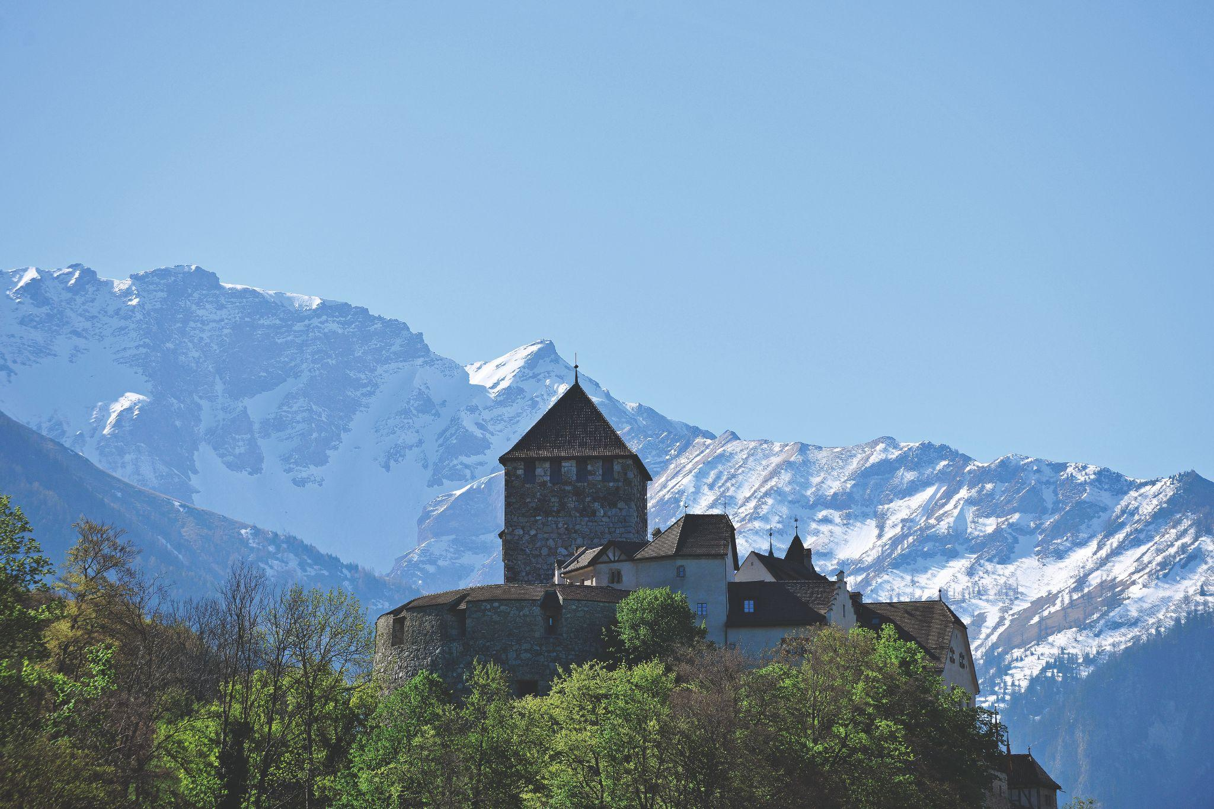
Link to high-res images here.

- Borders four countries: Germany, Switzerland, Austria, and Liechtenstein – all easily explored in one trip.
- Offers year-round experiences, from lakeside relaxation and cycling to skiing and festive winter markets.
- Rich cultural heritage, including medieval castles, Baroque churches, museums, and traditional festivals.

Lovingly called ‘Bodensee’ by locals, Lake Constance is a quintessential European destination where natural beauty, culture, and leisure converge across Germany, Switzerland, Austria, and Liechtenstein. Its sparkling waters shimmer in every shade of blue and green, framed by dramatic Alpine peaks, creating the perfect setting for year-round getaways.

Culture, Heritage, and Adventure
The region’s nostalgic traditions, including Fasnacht (carnival), coexist with baroque castles, historic churches, lush gardens, fruit orchards, and scenic vineyards. Visitors can explore the medieval Meersburg Castle, cycle along the Swiss shoreline, or take in panoramic vistas from Austria’s Pfänder mountain. Families will delight in Affenberg Salem, where Barbary apes interact up close, or enjoy scenic boat trips across the lake. The Bodensee Card PLUS unlocks access to over 160 attractions, from museums and castles to mountains and family-friendly theme parks.
Food and Drink
Lake Constance is a paradise for food lovers. Savor freshly caught whitefish, aromatic vegetables from UNESCO-protected Reichenau Island, regional cheese fondue, and local Müller-Thurgau wine. Lakeside dining at sunset is an unforgettable experience.
Relaxation and Wellness
Unwind in the region’s renowned thermal spas in Meersburg, Constance, and Überlingen. Indulge in massages, spa hopping, or natural moor baths. In winter, the lake transforms into a serene escape featuring skiing, Christmas markets, and the vibrant Alemannic Carnival.
Experiences Not to Miss
- Panoramic Zeppelin Flights over Friedrichshafen: See the region from above in a state-of-the-art airship, gliding over sparkling waters, vineyards, and the Alpine backdrop for an unforgettable perspective.
- Mainau, the Island of Flowers: Wander through gardens bursting with seasonal blooms, fragrant rose terraces, and exotic palm houses. Perfect for families, couples, and nature lovers alike.
- Rhine Falls, Europe’s Largest Waterfall: Marvel at the Rhine as it plunges 75 feet, creating misty rainbows and breathtaking scenery. Explore observation decks, take boat trips, and visit nearby historic castles.
- Cultural and Outdoor Activities: From cycling scenic lakeside paths and hiking rolling hills to visiting world-class museums, historic castles, and lively theme parks, Lake Constance has something for every interest and age. Don’t miss local markets, seasonal festivals, and traditional cultural events.
//

NOTES TO EDITOR
Top accommodation options:
- Seegut Zeppelin, Friedrichshafen (Germany) – Classic lakeside elegance with Alpine views.
- Hotel Einstein, St. Gallen (Switzerland) – Modern comfort with historic charm.
- Hotel Flow, Eschen (Liechtenstein) – Contemporary design in tranquil surroundings.
Average Hotel Rates - From €100–€250 (approx. $117-$292) depending on location and season.
Getting there from US:
- Flights: Major U.S. airports connect to Zurich and Munich. Zurich is only one hour by train to Constance or St. Gallen.
- Trains: Efficient German and Swiss rail networks make it easy to reach towns around the lake.
- Ferries: Regular passenger ferries connect lakeside towns, offering scenic and leisurely travel.
About Lake Constance:
The heart of Europe, one lake, four countries. The Lake Constance region, lovingly called ‘Bodensee’ by local residents, borders Germany, Austria, Switzerland and is just a short hop from the Principality of Liechtenstein. This international region benefits from magnificent views of the Alps. Visitors can choose to drive or cycle along rolling hills, past apple orchards and vineyards, visit Baroque churches and castles or take a dip in Europe’s third largest freshwater lake.

For media enquiries please contact:
Alina Milz: milz@bodensee.eu
International Bodensee Tourismus GmbH
Hafenstrasse 6, 78462 Constance, Germany
Tel. +49 (0) 7531 / 909490 | Fax +49 (0) 7531 / 909430
office@bodensee.eu

For more information about Lake Constance please visit:
https://www.bodensee.eu/en
Follow on Social:

- Instagram: @bodensee.eu
- Facebook: https://www.facebook.com/bodensee.eu

