UK General Release
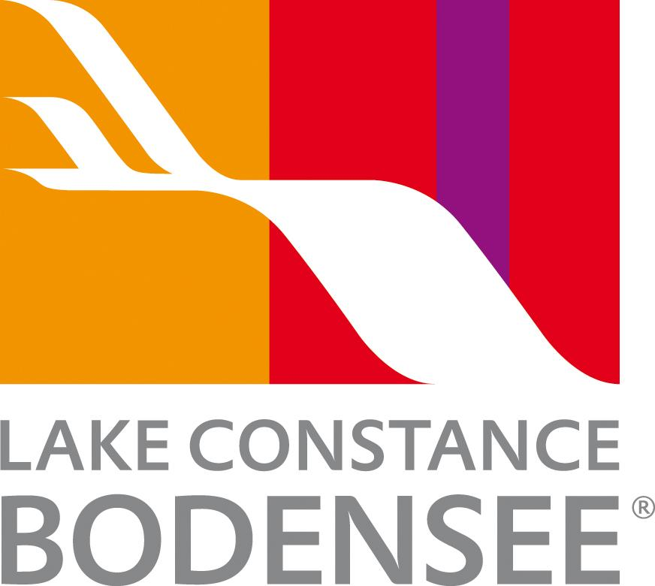

Lake Constance: Europe’s Timeless Crossroads

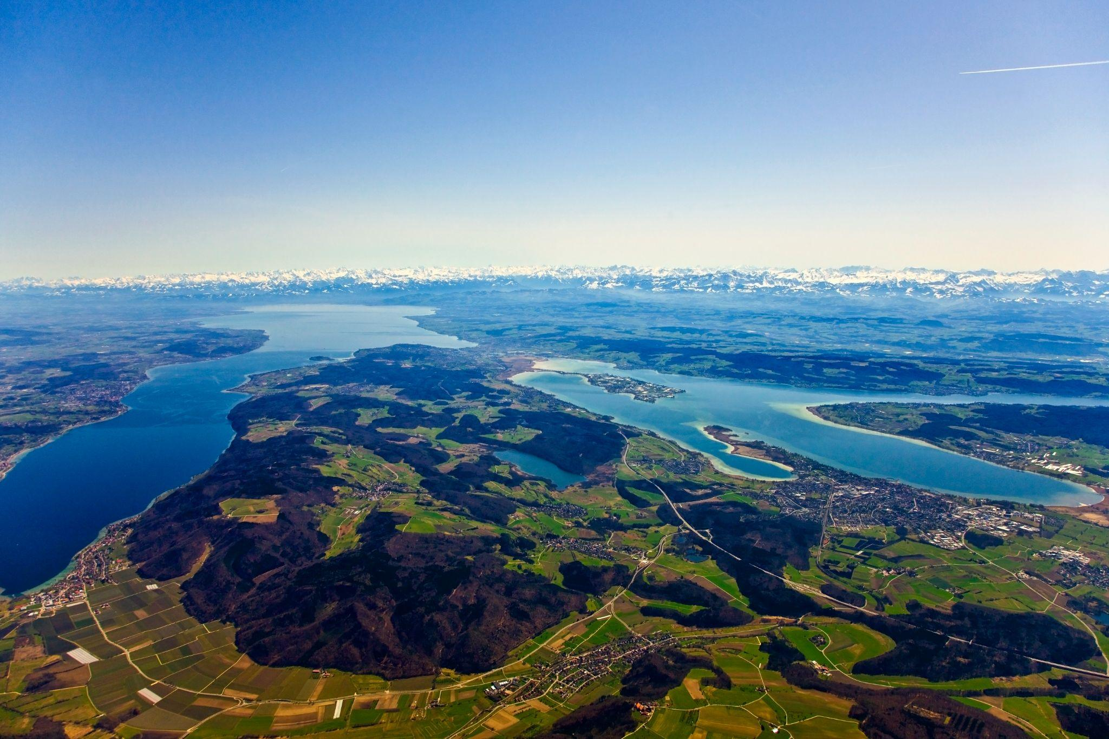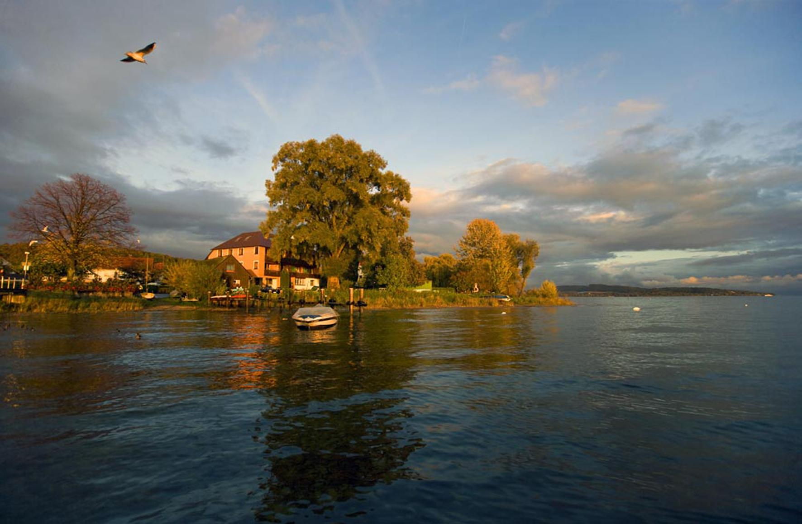
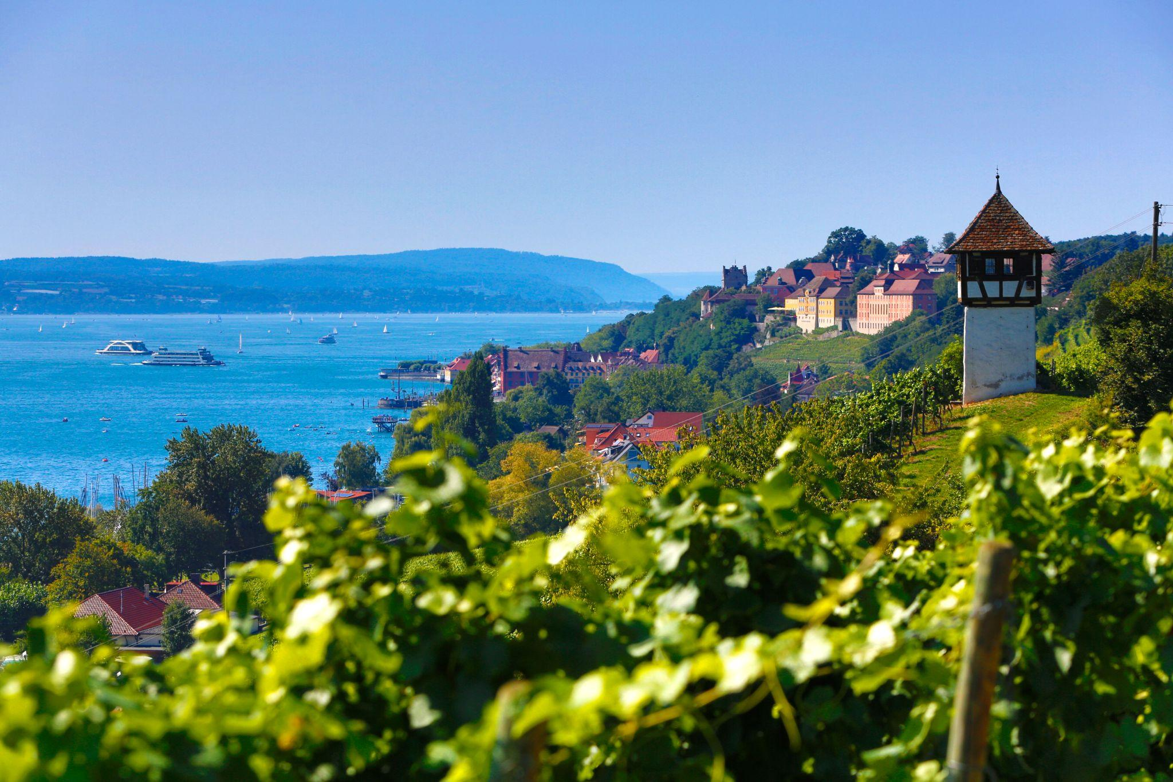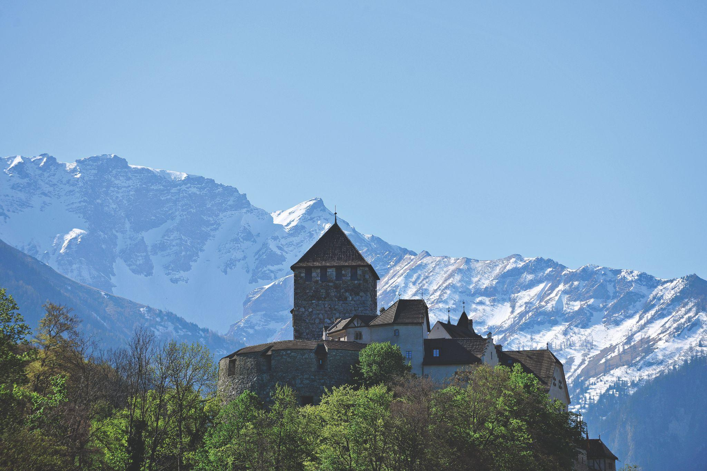
Link to high-res images here.

- Borders four countries: Germany, Switzerland, Austria, and Liechtenstein.
- Offers year-round experiences, from lakeside relaxation and cycling to skiing and winter markets.
- Rich cultural heritage, including medieval castles, baroque churches, museums, and traditional festivals.

Lovingly called ‘Bodensee’ by locals, Lake Constance is a destination, where natural beauty, culture, and leisure converge across Germany, Switzerland, Austria, and Liechtenstein. Its waters glimmer in every shade of blue and green, framed by the dramatic Alpine backdrop, offering a perfect setting for year-round retreats.

Culture, Heritage, and Adventure
The region’s nostalgic traditions, including Fasnacht (carnival), coexist with baroque castles, churches, lush gardens, fruit orchards, and vineyards. Guests can explore medieval Meersburg Castle, cycle along the Swiss shore, or take in panoramic views from Austria’s Pfänder mountain. Families can enjoy unique wildlife encounters at Affenberg Salem or a boat trip across the lake’s scenic waters. The Bodensee Card PLUS unlocks over 160 attractions, from museums and castles to mountains and theme parks.

Food and Drink
From aromatic vegetables from UNESCO-protected Reichenau Island to regional cheese fondue and local Müller-Thurgau wine, Lake Constance offers gastronomic delights for every taste.

Relaxation and Wellness
Visitors can unwind in thermal spas in Meersburg, Constance, and Überlingen, indulge in massages, spa-hopping, or natural moor baths. In winter, the region transforms into a serene escape with skiing, Christmas markets, and Alemannic Carnival festivities.

Experiences Not to Miss
- Panoramic Zeppelin flights over Friedrichshafen: Experience the Lake Constance region from above in a state-of-the-art airship. Glide over shimmering waters, vineyards, and the dramatic Alpine backdrop for a truly unforgettable perspective.
- Mainau, the Island of Flowers: Stroll through lush gardens bursting with seasonal blooms, fragrant rose terraces, and exotic palm houses. Perfect for families, couples, and nature lovers alike, Mainau is a visual feast in every season.
- Rhine Falls, Europe’s largest waterfall: Witness the awe-inspiring power of the Rhine as it plunges 23 metres, creating misty rainbows and dramatic scenery. Visitors can explore observation decks, boat trips, and nearby historic castles.
- Cultural and outdoor activities, from cycling and hiking to museum visits and theme parks: From cycling along scenic lakeside paths and hiking through rolling hills to visiting world-class museums, historic castles, and lively theme parks, Lake Constance offers a wealth of options for every interest and age. Don’t miss seasonal events, traditional festivals, and local markets that bring the region’s rich culture to life.

//

NOTES TO EDITOR
Top accommodation options:
- Seegut Zeppelin, Friedrichshafen (Germany) – Classic lakeside elegance with Alpine views.
- Hotel Einstein, St. Gallen (Switzerland) – Modern comfort with historic charm.
- Hotel Flow, Eschen (Liechtenstein) – Contemporary design in tranquil surroundings.
Average Hotel Rates - From €100–€250 (approx. £87-£217) depending on location and season.
Getting there from UK:
- Flights: Direct flights from London, Manchester, and other major UK airports to Zurich, Memmingen and Munich. Limited direct flights from the UK into the closest airport, Friedrichshafen.
- Trains: Efficient links via German and Swiss rail networks; Zurich Airport is a key gateway, only 1 hour by train to Constance or St. Gallen.
- Ferries: Regular passenger ferries connect towns across the lake, offering scenic travel.
About Lake Constance:
The heart of Europe, one lake, four countries. The Lake Constance region, lovingly called ‘Bodensee’ by local residents, borders Germany, Austria, Switzerland and is just a short hop from the Principality of Liechtenstein. This international region benefits from magnificent views of the Alps. Visitors can choose to drive or cycle along rolling hills, past apple orchards and vineyards, visit Baroque churches and castles or take a dip in Europe’s third largest freshwater lake.

For media enquiries please contact:
Alina Milz: milz@bodensee.eu
International Bodensee Tourismus GmbH
Hafenstrasse 6, 78462 Constance, Germany
Tel. +49 (0) 7531 / 909490 | Fax +49 (0) 7531 / 909430
office@bodensee.eu

For more information about Lake Constance please visit:
https://www.bodensee.eu/en
Follow on Social:
- Instagram: @bodensee.eu
- Facebook: https://www.facebook.com/bodensee.eu

