US Active Release

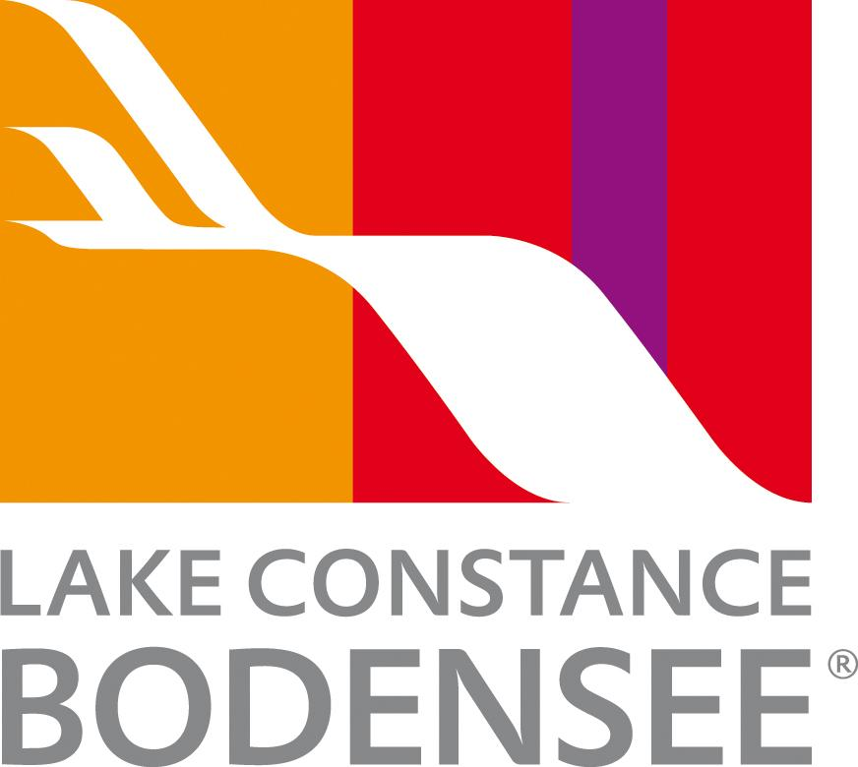

Lake Constance: Four Countries. One Lake. Endless Adventure.

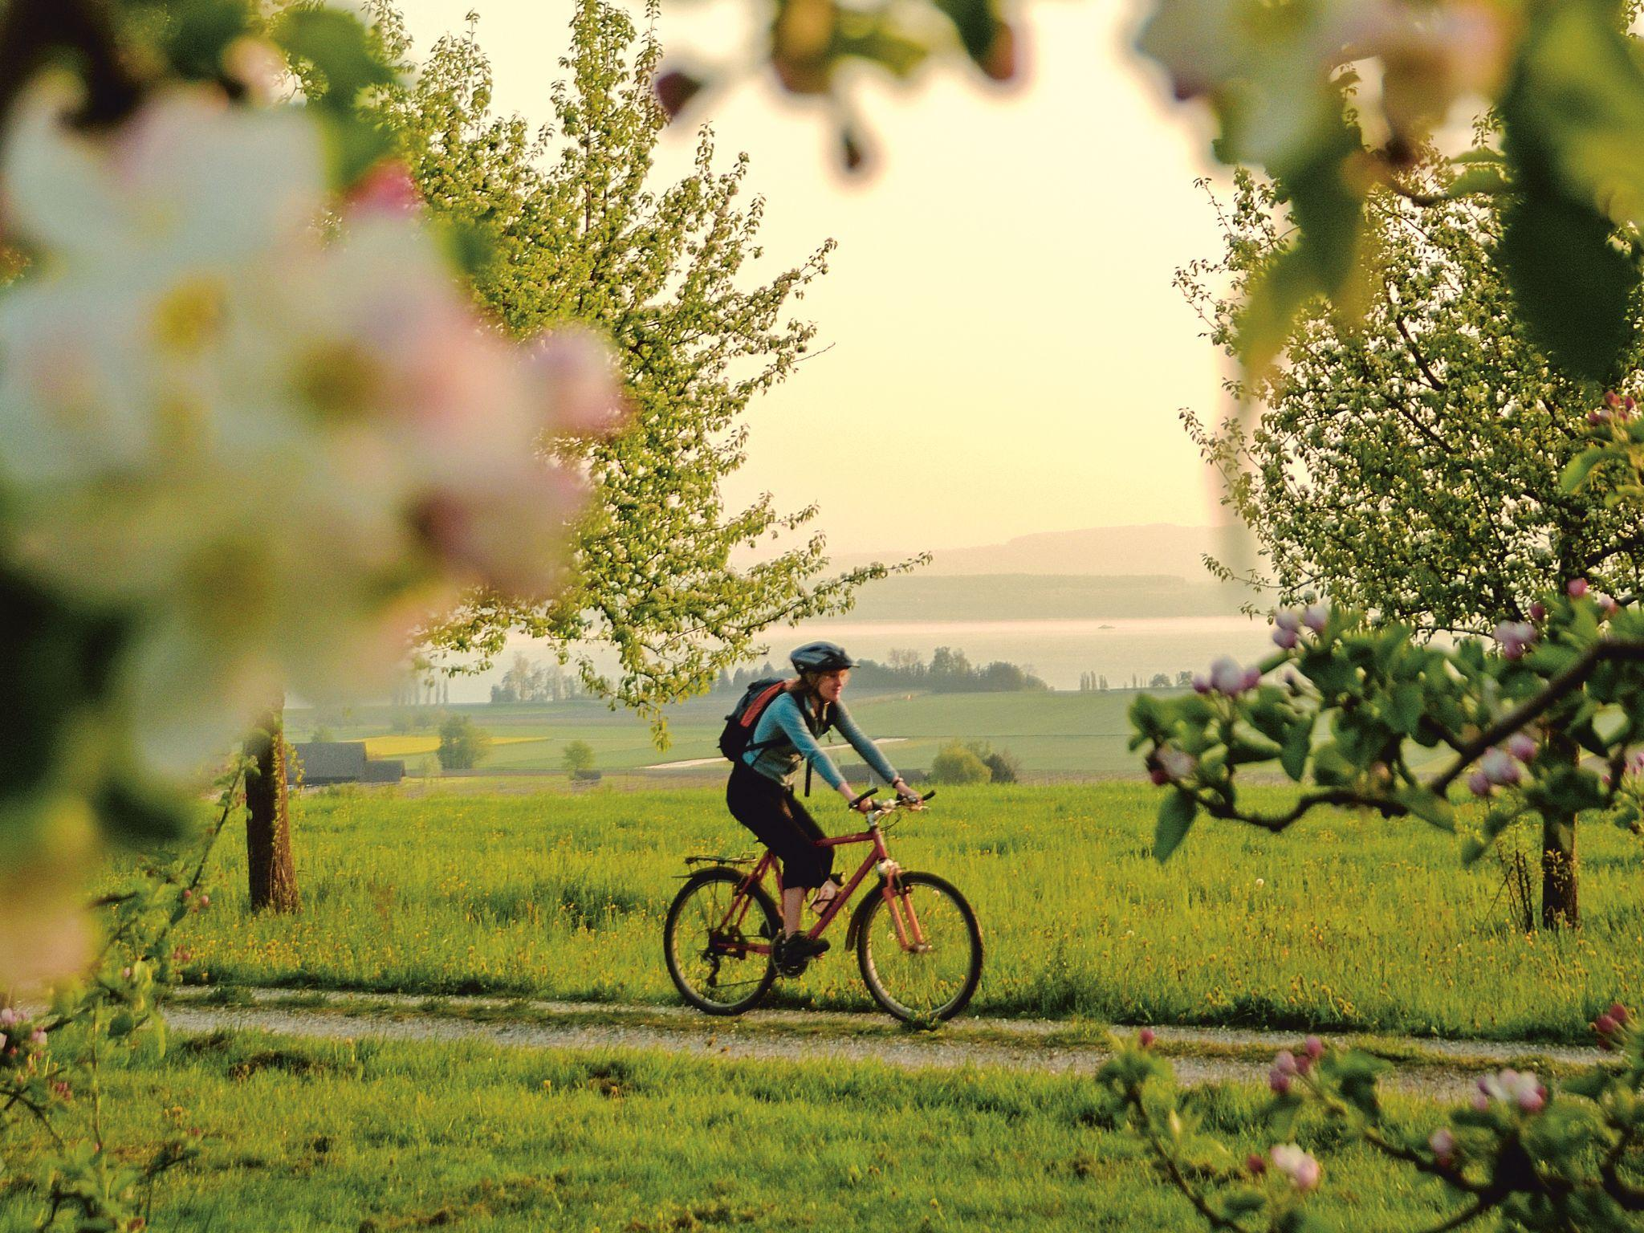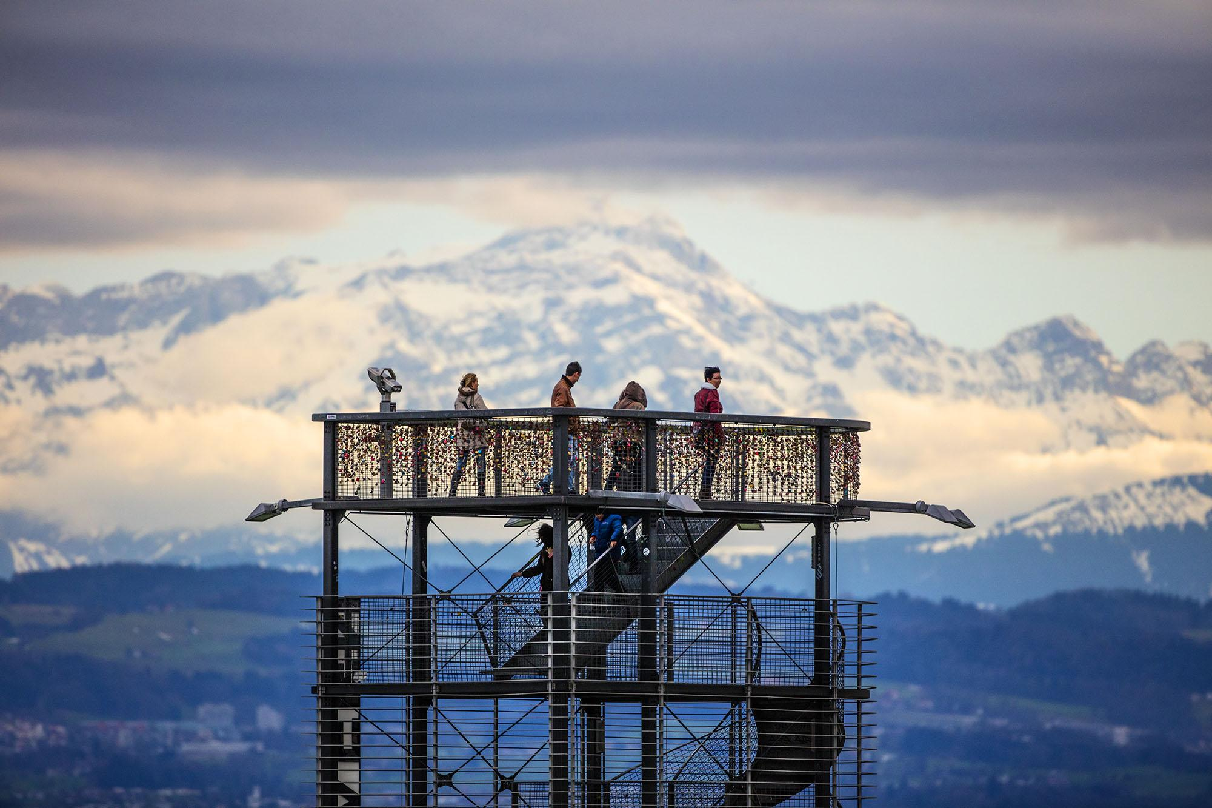
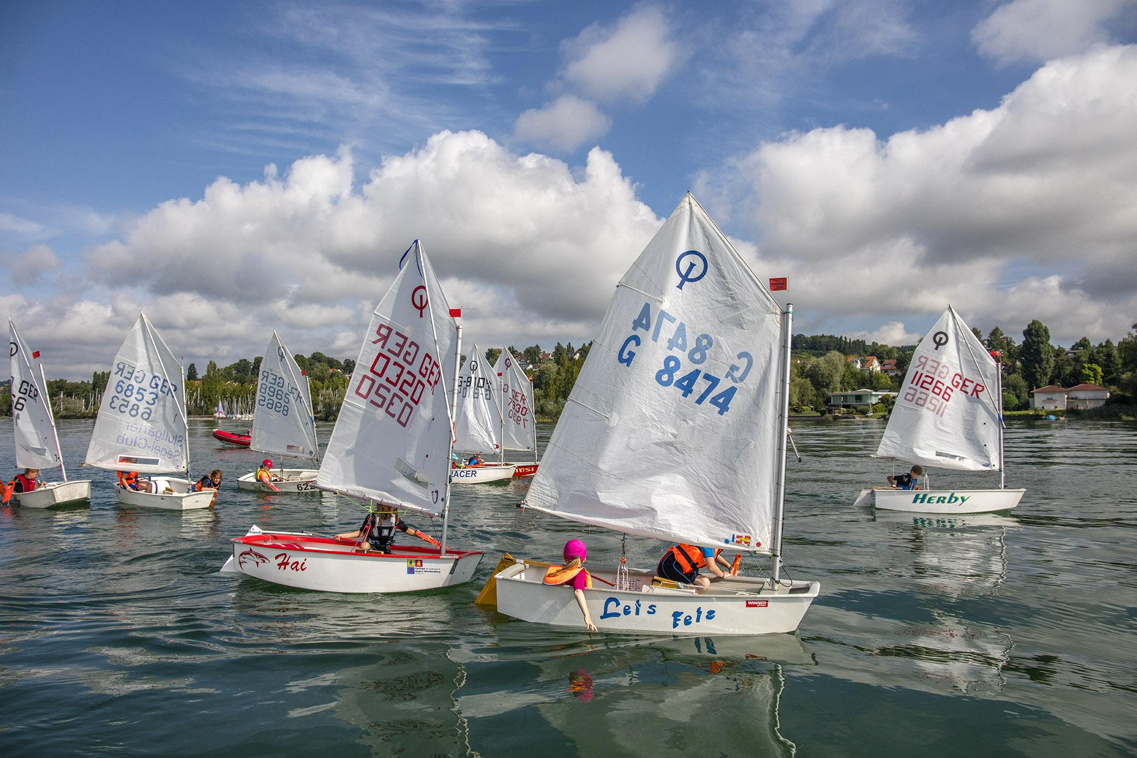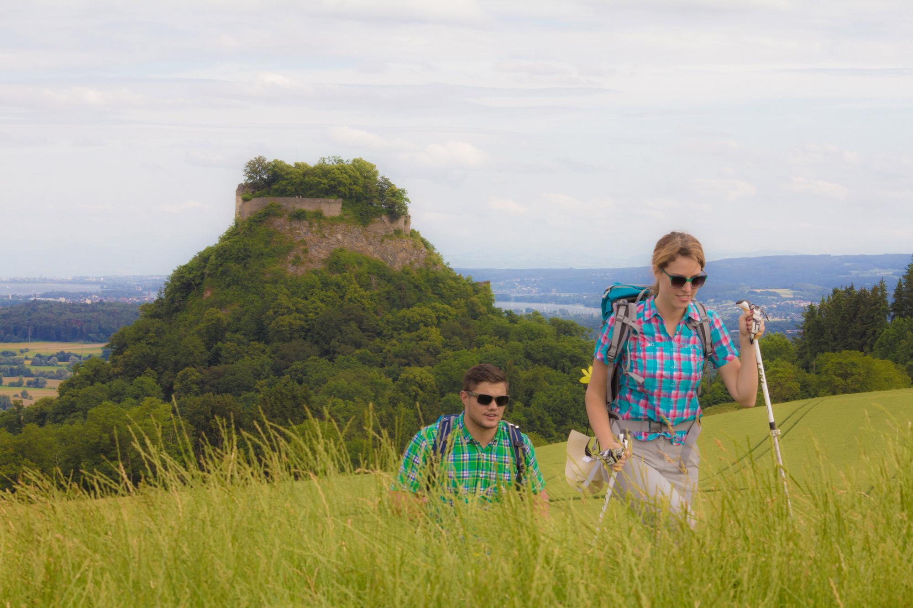
Link to high-res images here.
- Explore Germany, Switzerland, Austria, and Liechtenstein – all in one trip
- Cycle, hike, or paddle: Scenic trails, lakeside paths, and water adventures for every level.
- Adrenaline and outdoor thrills: Mountain peaks, zip lines, marathons, and multi-sport events.
- Family-friendly fun: Wildlife encounters, treetop parks, castles, and unforgettable lakeside experiences.

A quintessential European adventure
Known locally as Bodensee, Lake Constance is a playground for outdoor enthusiasts of all ages. With its shimmering waters, lush vineyards, and mountain backdrops, this region at the crossroads of Germany, Austria, Switzerland, and Liechtenstein is perfect for those seeking adventure, scenery, and a taste of authentic European charm.

Hiking Highlights
Hikers will find countless trails winding through four countries - each with its own character and breathtaking views. Clearly marked paths such as the Bodensee LandGänge and SeeGang lead through vineyards, orchards, lakeside towns, and rolling hills. For unbeatable panoramas, take the Säntis or Pfänder cableways up into the mountains, where trails skirt alpine peaks and meadows. Whether you’re planning a gentle day hike or a multi-day trek, detailed maps and routes make it easy to explore at your own pace.
Top Routes:
- Bodensee LandGänge: Located north of Lake Constance, this award-winning network of circular trails offers pristine countryside paths that lead to ‘country loungers’ and benches with breathtaking views over the lake.
- SeeGang Trail: A 33-mile (53 km) premium route connecting the towns of Constance and Überlingen. The trail can be shortened by boat, bus, or train, making it accessible to all fitness levels. Recognized by the German Hiking Institute as one of Baden-Württemberg’s most beautiful premium trails.

Cycling around the lake
The Bodensee Radweg (Lake Constance Cycle Route) loops more than 160 miles (260 km) around the lake, offering diverse terrain and endless views. Perfect for riders of all abilities, the route can be started anywhere, with countless places to stop for lakeside meals, local wines, and cultural discoveries.
Highlights for Cyclists:
- Lakeside trails with stunning views of the Alps.
- Scenic villages for food, wine, and local charm.
- Bike rentals and guided tours for every level, including with partners like Radweg-Reisen and Velotours.
- Many hotels and guesthouses along the route offer secure bike storage and rider-friendly amenities. See full list here.

Dive into Water Adventures
Lake Constance is a paradise for water sports. Whether you’re sailing, kayaking, paddleboarding, or windsurfing, the lake’s clear waters and gentle breezes set the perfect stage for adventure. Top providers like MB Events (Radolfzell and Moos, Germany) and Surfmax (Hard, Austria) offer lessons, rentals, and guided tours for all skill levels.
Top Water Activities:
- Sailing along sparkling shores and hidden coves.
- Kayaking through tranquil inlets and rivers.
- Paddleboarding and windsurfing in calm or breezy conditions.
- Cool off at lakeside beaches like Kressbronn Natural Beach or Moos Beach, where families can relax, swim, and enjoy stunning sunset views.

Family fun
Lake Constance keeps families entertained year-round—thanks to its castles, zoos, beaches, and nearby Alps.
- Spring: Stroll along fairytale and themed trails surrounded by blooming gardens.
- Summer: Visit natural beaches with water playgrounds or join a pirate ship treasure hunt from Immenstaad or Langenargen.
- Autumn: Try high ropes courses or treetop walkways surrounded by golden leaves.
- Winter: Explore child-friendly museums, frozen lakes, and snow adventures in the nearby Malbun family ski resort.

Key active events
Lake Constance’s global appeal shines through its top outdoor events - attracting athletes and spectators from around the world:
Sparkasse 3-Länder-Marathon – October 11, 2026
Run across three countries - Germany, Austria, and Switzerland - in one incredible marathon. Starting in Lindau, Germany, and finishing in Bregenz, Austria, this 26.2-mile (42.195 km) course winds through picturesque lakeside trails and historic towns. With options including a half marathon, quarter marathon, and Nordic walking, it’s ideal for all experience levels.
Bodensee Radmarathon – September 12, 2026
Cycling enthusiasts can test their limits on one of five routes, ranging from 30 to 135 miles (50–220 km). Organized by RV Altenrhein, this international cycling event celebrates endurance, camaraderie, and breathtaking scenery across Germany, Austria, and Switzerland.
NOTES TO EDITOR
Getting there from US:
- Flights: Major U.S. airports connect to Zurich and Munich, with limited flights to Friedrichshafen. Zurich is only one hour by train to Constance or St. Gallen.
- Trains: Efficient German and Swiss rail networks make it easy to reach towns around the lake.
- Ferries: Regular passenger ferries connect lakeside towns, offering scenic and leisurely travel.
About Lake Constance:
The heart of Europe, one lake, four countries. The Lake Constance region, lovingly called ‘Bodensee’ by local residents, borders Germany, Austria, Switzerland and is just a short hop from the Principality of Liechtenstein. This international region benefits from magnificent views of the Alps. Visitors can choose to drive or cycle along rolling hills, past apple orchards and vineyards, visit Baroque churches and castles or take a dip in Europe’s third largest freshwater lake.

For media enquiries please contact:
Alina Milz: milz@bodensee.eu
International Bodensee Tourismus GmbH
Hafenstrasse 6, 78462 Constance, Germany
Tel. +49 (0) 7531 / 909490 | Fax +49 (0) 7531 / 909430
office@bodensee.eu

For more information about Lake Constance please visit:
https://www.bodensee.eu/en
Follow on Social:
- Instagram: @bodensee.eu
- Facebook: https://www.facebook.com/bodensee.eu

