UK Active Release

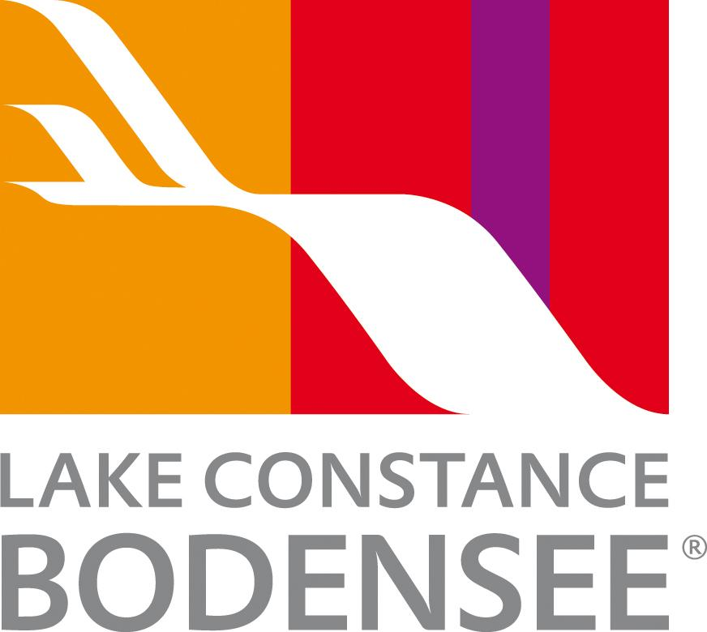

Lake Constance: Four Countries. One Lake. Endless Adventure.

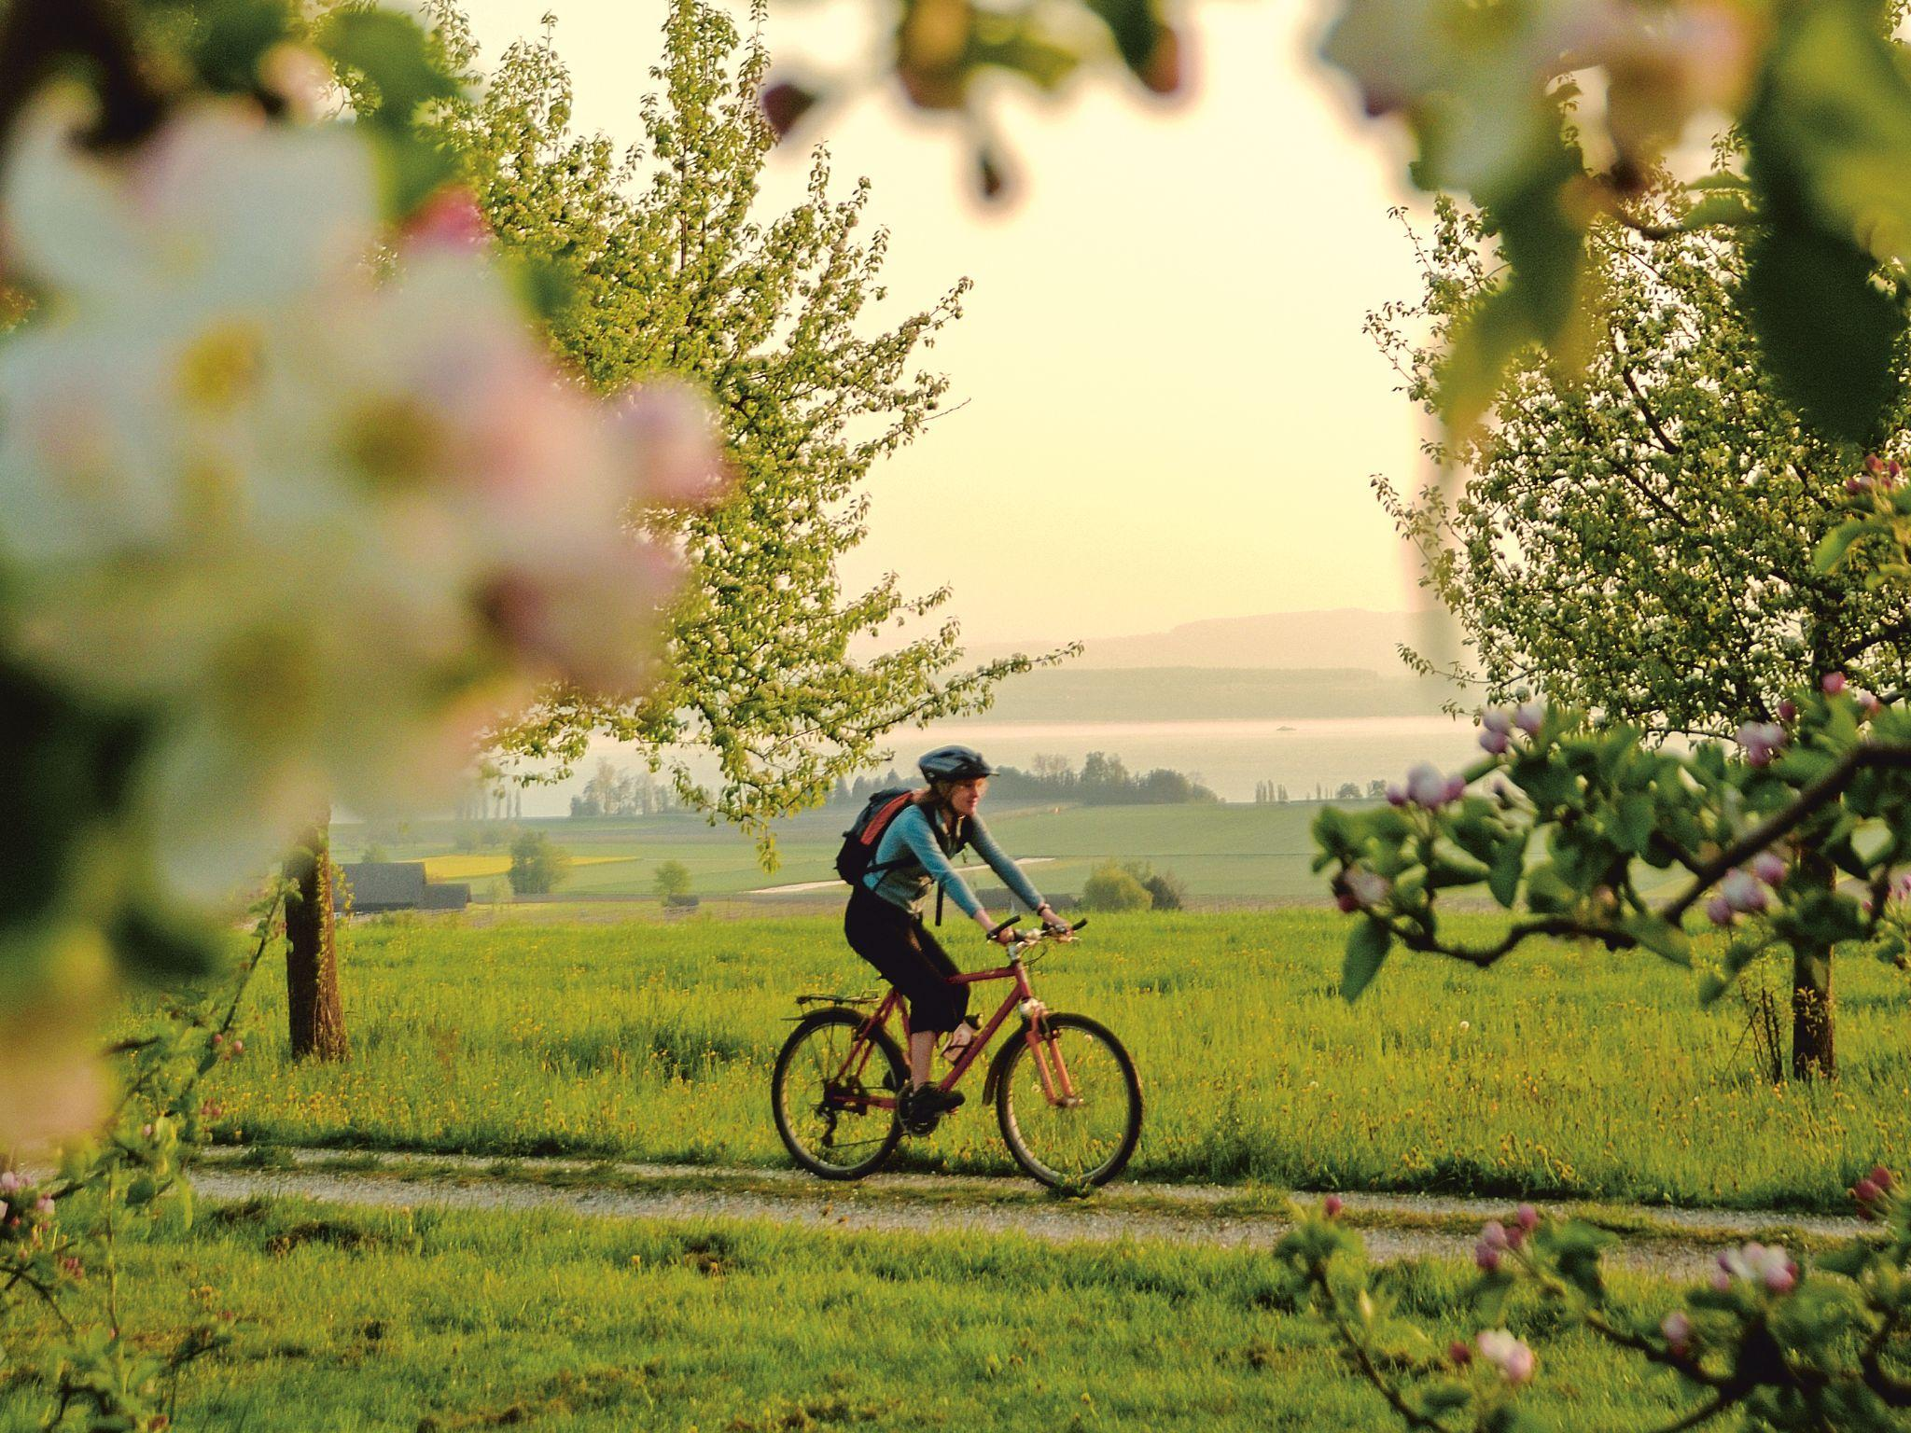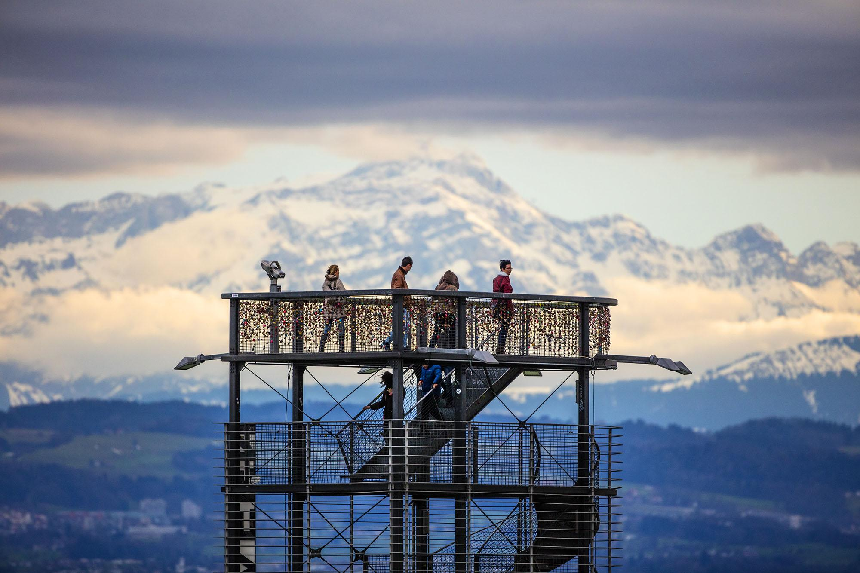
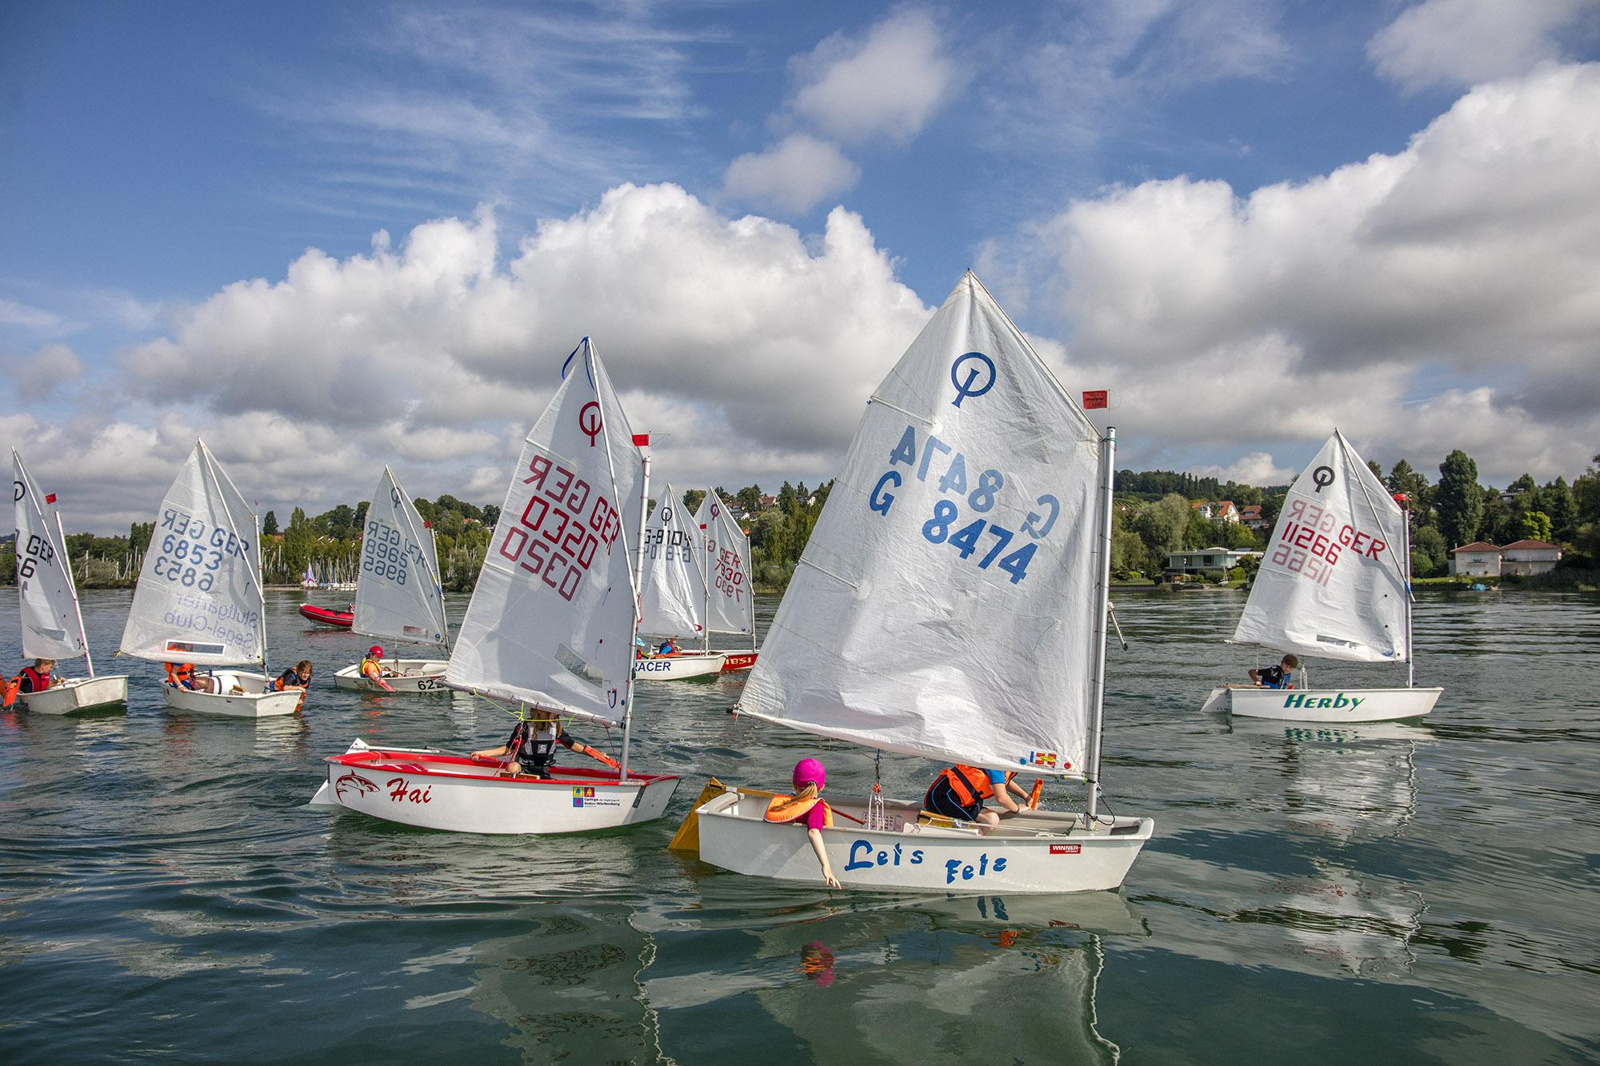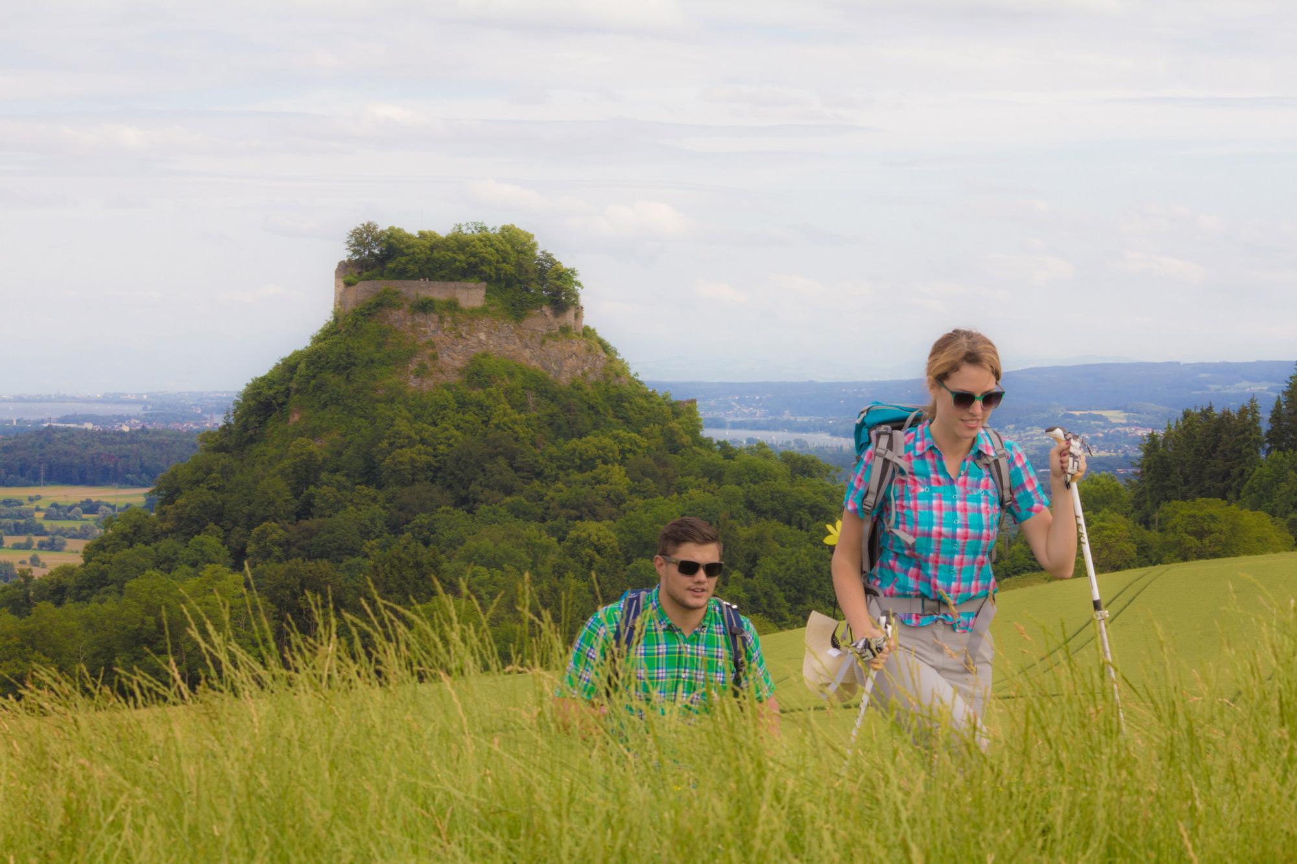
Link to high-res images here.

- Borders Germany, Switzerland, Austria, and Liechtenstein – explore four countries in one trip
- Cycle, hike, or paddle: Trails, lakeside paths, and water sports for all ages and abilities.
- Adrenaline and outdoor thrills: Mountain peaks, zip-lines, marathons, and multi-sport events across the region.
- Family-friendly action: Unique wildlife encounters, climbing parks, and unforgettable lakeside experiences.

Lake Constance - or Bodensee, as the locals call it - is a playground for outdoor enthusiasts of all ages. Its sparkling waters, lush hinterlands, and surrounding mountains make it the perfect destination for those seeking an adventure.
Hiking highlights
Hikers will find trails to suit every ability across four countries. Signposted paths such as the Bodensee LandGänge and SeeGang meander through vineyards, orchards, lakeside resorts, and rolling hills. For panoramic views, take the Säntis or Pfänder Cableway to reach mountain trails skirting alpine peaks. Maps and route details are available for all trails, making it easy to plan a day hike or a multi-day trek.
Top routes:
- Bodensee LandGänge - The Gehrgenberg-Bodensee region lies north of Lake Constance and offers pristine nature not far from the lakeshore. The award-winning circular hiking trails run along forest and field paths and repeatedly lead to so-called ‘Landliege’ (country loungers) and ‘Landbanken’ (country benches) that offer fascinating views of Lake Constance.
- SeeGang Trails - This 53-kilometer premium hiking trail connects the Lake Constance towns of Constance and Überlingen . The route can be shortened by boat, bus, or train, depending on your fitness level. Based on the number of points awarded by the German Hiking Institute, the SeeGang is the most beautiful premium hiking trail in the Baden-Württemberg region.

Cycling around the lake
The Bodensee Radweg (Lake Constance Cycle Route) circles the lake for over 260 km (160 miles), offering varied terrain and stunning views. Routes are suitable for all abilities, with flexible start and endpoints. Visitors can hire bikes locally or take guided tours with operators such as Radwegreisen and Velotours.
Highlights for cyclists:
- Lakeside paths with panoramic views of the Alps.
- Scenic village stops for food, wine, and local culture.
- Bike hire and guided tours available for all skill levels.
- See here for a list of hotels and guesthouses close to bike trails and offer bike storage.

Dive into watersports
Whether it’s sailing, kayaking, stand-up paddleboarding, or windsurfing, Lake Constance is made for water lovers. Providers like MB Events in Radolfzell and Moos, and Surfmax in Hard, Austria, offer lessons, equipment hire, and guided tours for beginners and experienced enthusiasts alike.
Top water activities:
- Sailing along the lake’s sparkling shores.
- Kayaking through quiet coves and rivers.
- Paddleboarding and windsurfing in calm or breezy conditions.
- There are also a number of lakeside beaches to enjoy! Including Kressbronn Natural Beach and Moos Beach.

Family fun
Lake Constance is packed with activities that keep children and adults entertained year-round. Castles, palaces, zoos, sparkling waters, and the nearby Alps ensure that boredom doesn’t stand a chance.
- Spring: As the plants begin to bloom, stroll along fairytale and themed trails, enjoying vibrant gardens and scenic lakeside paths.
- Summer: Head to a natural beach with a water playground, or hop aboard pirate ships from Immenstaad or Langenargen for an exciting treasure hunt.
- Autumn: High ropes courses, treetop walkways, and colorful landscapes offer fun and adventure with impressive views.
- Winter: Enjoy child-friendly museums, fairytale castles, ice rinks, or try snow adventures at the nearby Malbun family ski resort.

Key active events
Lake Constance's international appeal is showcased through two premier active events that attract people from around the globe:
Sparkasse 3-Länder-Marathon - 11 October 2026
This marathon offers runners the opportunity to traverse three countries - Germany, Austria, and Switzerland in a single race. The 42.195 km course begins in Lindau, Germany, and finishes in Bregenz, Austria, passing through scenic lakeside paths and charming towns. The event includes various race categories, such as the full marathon, half marathon, quarter marathon, and Nordic walking, catering to participants of all levels.
Bodensee Radmarathon - 12 September 2026
Cycling enthusiasts can challenge themselves with one of five routes ranging from 50 km to 220 km, starting from various locations around Lake Constance. Organised by the RV Altenrhein cycling club, this event offers participants the chance to experience the diverse landscapes of Germany, Austria, and Switzerland, all while enjoying excellent rider support and camaraderie.
NOTES TO EDITOR
Getting there from UK:
- Flights: Direct flights from London, Manchester, and other major UK airports to Zurich, Memmingen and Munich. Limited direct flights from the UK into the closest airport, Friedrichshafen.
- Trains: Efficient links via German and Swiss rail networks; Zurich Airport is a key gateway, only 1 hour by train to Constance or St. Gallen.
- Ferries: Regular passenger ferries connect towns across the lake, offering scenic travel.
About Lake Constance:
The heart of Europe, one lake, four countries. The Lake Constance region, lovingly called ‘Bodensee’ by local residents, borders Germany, Austria, Switzerland and is just a short hop from the Principality of Liechtenstein. This international region benefits from magnificent views of the Alps. Visitors can choose to drive or cycle along rolling hills, past apple orchards and vineyards, visit Baroque churches and castles or take a dip in Europe’s third largest freshwater lake.

For media enquiries please contact:
Alina Milz: milz@bodensee.eu
International Bodensee Tourismus GmbH
Hafenstrasse 6, 78462 Constance, Germany
Tel. +49 (0) 7531 / 909490 | Fax +49 (0) 7531 / 909430
office@bodensee.eu

For more information about Lake Constance please visit:
https://www.bodensee.eu/en
Follow on Social:
- Instagram: @bodensee.eu
- Facebook: https://www.facebook.com/bodensee.eu

