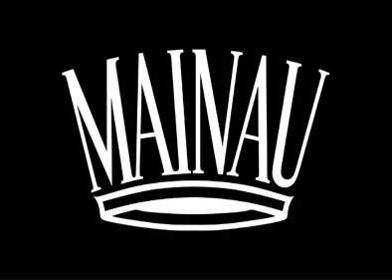

Press-Release

Baobab and Bonobo
Fascination Africa on Mainau Island

The 2018 motto for Mainau Island on Lake Constance takes its name from the planet’s 2nd largest continent. “Baobab and Bonobo – Fascination Africa.” Africa represents a great diversity of culture and nature and Mainau’s interpretation includes a wild jungle landscape of orchids, a four-meter replica of the Cheops Pyramid complete with a sand Sphinx. The grounds of the eighteenth-century Baroque Palace feature an east African grassland with five stylized savanna animals that visitors can walk through. The view from the Mediterranean terraces stretches across Lake Constance to the Alps, while countless African lilies dance on the lake breeze.

The 2018 flower season on Mainau Island kicks off with the annual orchid show in the Palm House, showcasing the flair of the central-African rainforest. This year’s theme “On Tarzan’s Windowsill” (March 16 - May 6) features many orchid varieties including the Bulbophyllum species. Visitors can also see photographs by the internationally acclaimed nature photographer Christian Ziegler showing Bonobo Monkeys from the Congolese rainforest — relatives of chimpanzees.

This year’s African theme also finds its way into the Butterfly House, one of Germany’s largest. Moths native to Africa flutter through this tropical plant world primarily in May and June. The temporary West African farmer’s garden features cultivated plants. Among a variety of South African plants planted on the Mediterranean terraces, the African lily (Agapanthus) blooms in July and August.

The annual fall exhibit in the Palm House marks the end of the flower season. This year’s show “Coffee — Africa’s Gift to the World” (September 21 - October 21) is dedicated to coffea arabica from the central African highlands. Another exhibit explores among other topics autumnal bird migration from Lake Constance to Africa (June 8 - August 26). In collaboration with the Max-Planck-Institute for Ornithology in Radolfzell, the exhibition in the Baroque Palace explains the institute’s animal observation system (ICARUS), which allows researchers to study animal movement data collected from the ISS space station.

Adventure Playgrounds and Mediterranean Blossoms
There are many other 2018 highlights starting with the massive annual tulip bloom, followed by an endless expanse of Rhododendrons, fragrant roses, perennials, and colorful dahlias. The majestic power of the arboretum park with its 150 year-old mammoth trees (giant sequoia) is impressive. Palm and citrus plants lend a decorative Mediterranean flair to the island. Children love the sprawling adventure playgrounds.

New to the botanical gardens is an 800 m² area dedicated to medicinal herbs with plants including motherwort, monk’s pepper and milk thistle used for healing effect throughout time in different cultures.

Events:
Count’s Island Festival: May 31 - June 3, 2018
Count’s Palace Festival: October 3 - 7, 2018
South African BBQ Night: August 3, 2018

Getting here:
Attractive combined tickets for island entry and arrival by train, bus and boat are available, for example at the Deutsche Bahn (www.bahn.de/baden-wuerttemberg), Lake Constance ship companies (www.bsb.de) and Swiss Railways (www.sbb.ch).

Calendar of Events and Information: www.mainau.de.

Updated: February 2018
Additional information for Media & Press Inquiries
Mainau GmbH, Phone: +49 7531/303-138, E-Mail: presse@mainau.de

